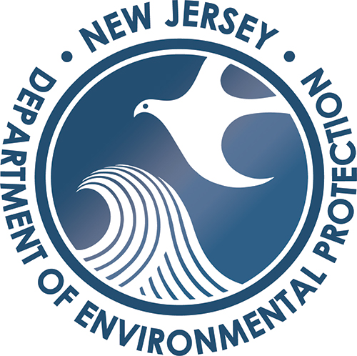
For more information, contact:
COUNTY EMERGENCY DEBRIS MANAGEMENT PLAN TEMPLATE AND INFORMATION PACKET

MAY 2024

Division of Sustainable Waste Management
Bureau of Solid Waste Permitting
Debris Management Team
401 E. State St.
P.O. Box 420, Mail Code 401-02C
www.nj.gov/dep/dshw/debris
(609) 633-1418
solidwasteemergencies@dep.nj.gov

EXECUTIVE SUMMARY

Certain emergency circumstances, such as natural disasters (e.g., hurricanes, tornadoes, floods, severe storms) and man-made disasters (e.g., hazardous materials incidents, acts of terrorism, outbreak of communicable diseases in people or animals) may cause the quantity of solid waste debris generated to exceed the capacity of a geographic area and prevent the ability of government or private entities to safely and effectively manage the solid waste debris in accordance with the State’s comprehensive regulatory standards. The purpose of an Emergency Debris Management Plan is to provide a means of guidance, planning, and preparation for such an event.

Depending on the circumstances of an event, it may be in the State’s interest to temporarily modify or waive certain requirements while still maintaining appropriate health, safety and environmental protections. The Governor of New Jersey may issue an Executive Order declaring a State of Emergency under the Disaster Control Act. N.J.S.A. App. A:9-30 et seq., which may authorize the New Jersey Department of Environmental Protection (NJDEP), if necessary, to temporarily relax some of its regulatory requirements under the environmental laws of the State in order to effectively, efficiently, and safely execute a debris management/removal program. This may include, but is not limited to: relaxation of regulatory requirements related to the Solid Waste Management Act, N.J.S.A. 13:1E-1 et seq. and the Solid Waste Utility Control Act, N.J.S.A. 48:13A-1 et seq. The implementation of a County Emergency Debris Management Plan will also support the State’s debris management and removal efforts in support of its goal to restore its communities to normalcy as quickly as possible after an event.

Additionally, a County’s Emergency Debris Management Plan will support recovery for localized events that do not result in an Executive Order by the Governor, but may be a declared emergency event by County or municipal officials.
This Emergency Debris Management Plan template and companion Guidance Handbook closely mirror the Federal Emergency Management Agency (FEMA) Public Assistance Debris Management Guide, FEMA-325 (July 2007) and incorporates information from the FEMA Public Assistance Debris Management Plan Workshop Student Handbook, the FEMA Public Assistance Debris Monitoring Guide, FEMA-327 (March 2021) and the FEMA Public Assistance Program and Policy Guide, FP 104-009-2 Version 4 (June 1, 2020).

OVERVIEW

The purpose of this Emergency Debris Management Plan toolkit is to provide a framework for the development and implementation of an Emergency Debris Management Plan. The Emergency Debris Management Plan should incorporate all elements involved in managing debris removal operations and be in support of New Jersey’s Statewide Debris Management Plan. The Plan should be designed to address circumstances wherein the normal capacity of the County to manage debris is exceeded by large scale or localized events including, but not limited to, hurricanes, tropical storms, tornados, fires, earthquakes and/or acts of terrorism.
This Emergency Debris Management Plan template and Guidance Handbook has been developed to provide the guidelines for New Jersey County governments to plan for, resource, and execute a program to clear, remove and dispose of debris generated during events or emergencies of varying scopes within the County. This template is designed to unify the efforts of the County for a comprehensive and effective approach to:

- Provide organizational structure, guidance, and standardized guidelines for the planning for, resourcing of, and assignment of roles and responsibilities before and during clearance, removal, and disposal of debris caused by a major debris-generating event.

- Recognize the phases of emergency debris management and effectively plan, anticipate, and transition through the phases of debris removal and disposal.

- Establish the most efficient and cost-effective methods for debris removal and disposal.

- Develop a plan and process that will maximize Federal Emergency Management Act Public Assistance reimbursement opportunities.

- Implement and coordinate shared services agreements and/or private sector debris removal and disposal contracts to maximize cleanup efficiencies.

- Expedite debris removal and disposal efforts to mitigate the threat to the health, safety, and welfare of County residents.

- Develop partnering relationships through communications and pre-planning efforts with local, state, and federal agencies that have debris management responsibilities.

This toolkit is organized into three documents: The Emergency Debris Management Plan template, the Guidance Handbook and an Emergency Debris Management Plan Fact Sheet. The Emergency Debris Management Plan template provides a boilerplate for all components that are necessary for forming a comprehensive Emergency Debris Management Plan and contains language to facilitate the development of a plan for your County. The Guidance Handbook is a companion document to the template and will provide step by step instructions, pre-planning information, and tips to assist you in writing your plan. The Emergency Debris Management Plan template is intended to be a guideline and is designed to provide basic background information regarding FEMA Public Assistance eligibility and processes. The County should ensure that its County-specific procedures are incorporated into the plan.

Should you have questions, or require additional assistance in developing your plan, a DEP staff member is available to assist you. Please email solidwasteemergencies@dep.nj.gov or contact Joseph Morad at joseph.morad@dep.nj.gov.

Upon completion of a draft Emergency Debris Management Plan, your County must submit the Plan to the New Jersey Office of Emergency Management (NJOEM) for review and approval. The NJDEP should be copied on the submittal. The NJOEM will conduct a preliminary review and forward the plan to the Federal Emergency Management Agency (FEMA) for final review.
EMERGENCY DEBRIS MANAGEMENT PLAN FACT SHEET

What is a debris generating event, and what types of debris are generated?

A debris generating event is generally characterized as a natural and/or man-made disaster which generates a large volume of debris. Debris generating events may include, but are not limited to: high winds, storm surge, tropical storms, hurricanes, nor’easters, fires, earthquakes, ice or snow storms, tornadoes, weapons of mass destruction, or acts of terrorism. These types of events may disburse all types of debris including vegetative matter, sand, putrescible waste/municipal solid waste, chemical and hazardous waste, boats, vehicles and construction materials. A large-scale event may quickly overwhelm normal waste disposal operations of a County.

A hurricane or nor’easter can generate high velocity winds, storm surge, wave action, and flooding. The most severe damage usually occurs along the shore, adjacent to the ocean. Hurricanes and nor’easters frequently generate debris such as vegetative matter, construction and demolition materials, marine vessels, and sediment. Based on the severity of the hurricane or nor’easter, an event may also generate a large volume of household waste if flooding is involved.

Tornados, although not common in New Jersey, can cause a large amount of damage due to high-velocity winds. Tornado debris commonly consists of vegetative debris, construction and demolition materials, and personal property.

Flooding can result from severe or long-lasting rainstorms, hurricanes or even reservoir or dam failure. High velocity water flow, such as that from overflowing rivers, can cause heavy damage to structures adjacent to the waterway. Flood debris may consist of sediment, construction and demolition materials, personal property and vehicles.

An urban fire or building explosion can result in a large amount of construction and demolition material debris as well as personal property and household debris. However, if a fire or explosion takes place at a commercial or industrial facility, there may also be hazardous waste and chemical waste.

Acts of terrorism present unique concerns. Debris generated by such an event can be highly variable in quantity and type. A debris generating event of this type may necessitate the involvement of law enforcement authorities, the coroner’s office and health officials before the debris is even handled.

A summary of debris generating events and the type of debris typically generated is provided below:

Cause of  Damage  Type of  Debris | Hurricane/  Nor’easter  - High winds  - Storm surge  - Flooding | Tornado  - High velocity winds | Flooding  - High velocity water flow  - River overflow  - Reservoir/ Dam failure | Fire/  Explosion
Vegetative | 
Sediment |  |  | 
Construction and Demolition | 
Bulky Solid Waste | 
Household Hazardous Waste | 
White Goods | 
Vehicles | 
E-Waste | 

Why should New Jersey Counties develop an Emergency Debris Management Plan?

In recent years, debris generating events in New Jersey have occurred more frequently. Between 1999 and 2010, a span of 11 years, there were fewer than seven major debris generating incidents in New Jersey. However, between August 2011 and June 2012, a span of ten months, there were five significant debris generating events. Shortly thereafter, in October 2012, Superstorm Sandy occurred. Superstorm Sandy was the most significant debris generating event to take place in New Jersey. As our climate changes, natural disasters are likely to become more frequent, and the State of New Jersey, its counties, and its municipalities must be prepared to handle these types of events. Man-made disasters also pose a threat to New Jersey. Planning for such an event will allow counties to implement debris removal and disposal operations more effectively and efficiently.

The Emergency Debris Management Plan should be implemented for Federally declared disasters which, due to their nature, may provide opportunities for your County to seek reimbursement from the Federal Emergency Management Act’s Public Assistance Program for some, or all, aspects of this Plan. However, the Plan should also be utilized in cases where the circumstances may not qualify your County for reimbursement.

EMERGENCY DEBRIS MANAGEMENT PLAN TEMPLATE

GUIDANCE HANDBOOK

This Guidance Handbook is meant as a companion guide to assist you in developing your County’s Emergency Debris Management Plan (Plan). It is strongly suggested that you review the FEMA Public Assistance Program and Policy Guide, FP 104-009-2 Version 4 (June 1, 2020), and the FEMA Public Assistance Debris Management Guide, FEMA-325 (July 2007) prior to starting work on your County Plan. These documents are available at www.fema.gov. Additional guidance documents and resources are listed throughout this document.

How to Use This Guidance Handbook

Each numbered section in this Guidance document corresponds to the same numbered section in the Plan template.

Each section is divided into four subsections:

Summary-Provides a general overview of what the section is about.

Questions to Consider-Lists items to think about, and answer, before beginning work on the section.

Task Checklist-Lists items that will need to be prepared for inclusion into the Emergency Debris Management Plan.

Resources-Lists guidance documents which provide more specific information on the section and its requirements.

How to Use the County Emergency Debris Management Template

The term “the County” is used throughout the Template document. Where applicable, you should replace “the County” with your specific County name.

Items highlighted in yellow generally denote a section in which the County needs to insert or provide County specific information. You should refer to the appropriate section of the Guidance Handbook if you require more detailed information regarding what information to insert.

Additionally, where indicated, the County may need to provide specific documents. These documents should be added as appendixes to this template for easy reference. There are certain documents and information which may be likely to change over time, such as personnel lists, or reference documents. Adding this information as an appendix will make it easier to keep your Plan up to date without having to change the contents of the plan itself.

Please note that the template should act as a baseline for development of your County Emergency Debris Management Plan. While certain aspects of the Plan must be included in order to be reviewed by FEMA, you should feel free to delete or add information as needed.

Getting Started

Decide which Departments within your County should be involved in the development of the Emergency Debris Management Plan. Usually, the Public Works and Engineering Department (ESF#3) is the primary group involved in developing a debris management plan. However, you may also consider involving the Office of Emergency Management, Transportation Department, the Health Department, Law Enforcement/Public Safety, Financial Department, and Legal Department.

Encourage all Departments involved to review FEMA Public Assistance Program and Policy Guide, FP 104-009-2 Version 4 (June 1, 2020), and the FEMA Public Assistance Debris Management Guide, FEMA-325 (July 2007) prior to starting work on the plan.

Review this Guidance Handbook and the Emergency Debris Management Plan template.

Decide how to approach the development of this debris management plan. Will the groups involved work on this together, or will specific sections be assigned to specific groups?

This plan should include the designation of the County’s Temporary Debris Management Areas (Section X). Since the County will need to receive pre-approval from NJDEP for its Temporary Debris Management Areas, it is suggested that you complete Section V, Debris Forecasting for a Design Event first, then submit the pre-approval applications for the Temporary Debris Management Areas to NJDEP.

EMERGENCY DEBRIS MANAGEMENT PROMULGATION SIGNATURE PAGE

Summary

This page is included to document that your County has endorsed its Emergency Debris Management Plan.

Questions to Consider

Who should sign this page on behalf of the County? NJDEP suggests, at a minimum, that a County Commissioner who oversees the County Office of Emergency Management and Solid Waste, the head of the County Office of Emergency Management, and the County Solid Waste Coordinator. However, the County should feel free to change these designations.

Task Checklist

Have the appropriate people sign this page.

Resources

None

RECORD OF CHANGES

Summary

This page is included to document any minor changes that your County makes in the Plan after it has been finalized. If any major revisions are made, the County should consider re-issuing the plan with the changes.

Questions to Consider

None

Task Checklist

Ensure that all necessary County personnel are notified of any changes made to the Plan.

Resources

None

RECORD OF DISTRIBUTION

Summary

This page is included to document which personnel have received a copy of the Plan.

Questions to Consider

Who should have a copy of this plan? NJDEP has included a list of suggested personnel on the page, however, the County should use its own discretion to determine who should receive a copy.

Task Checklist

Edit the “suggested personnel” section as necessary.

Fill out the form with the names and titles of personnel receiving the Plan.

Resources

None

PURPOSE

Summary

This section provides a narrative on the purpose of the Emergency Debris Management Plan. This section in the template is an example only, and your County should feel free to edit and/or revise its contents.

Questions to Consider
None

Task Checklist
Edit and/or revise the section if necessary.

Resources
None

SITUATIONS, PLANNING ASSUMPTIONS AND COUNTY DEMOGRAPHICS

Summary

This section provides a narrative on the general situations likely to be present during a debris generating event as well as certain planning assumptions and a section in which to detail your County demographics. The Situation section in the template is an example only, and your County should feel free to edit and/or revise its contents. The Planning Assumptions, while generic, should be specific to your County plan and should be edited or revised as necessary. The County Demographics section provides a brief summary of certain aspects of your County.

Questions to Consider

Does the template language in the Situation section apply to your Plan?

Does the template language in the Planning Assumptions apply to your Plan and your County? (specifically, the type of debris generating event your Plan is based upon)

What is the population of your County?

Where are the urban areas vs. the rural areas?

What types of geographical aspects border your County (lakes, rivers, mountains, coastal)?

How many county roads are present in your County? How many total miles?

Are there any critical facilities or infrastructure in your County? What are they and where are they located?

What, if any, specific challenges do the specific demographics of your County present?

Task Checklist

Edit and/or revise these sections as necessary.

Provide the appropriate information for your County demographics.

Resources

None

SECTION I
PUBLIC ASSISTANCE DEBRIS REMOVAL ELIGIBILITY OVERVIEW

Summary

This section provides a very general overview of the general eligibility requirements under the Federal Emergency Management Agency’s (FEMA) Public Assistance Program for Presidentially declared disasters.

Previous FEMA Guidance documents used the term “Grantee” to refer to a non-Federal entity that receives a Federal award directly from a Federal awarding agency to carry out an activity under a Federal program. That term is now known as “Recipient”, which, as it pertains to this document, is the State of New Jersey.

Previous FEMA Guidance documents used the term “Subgrantee” to refer to a non-Federal entity submitting an application to the Grantee (now known as Recipient) for assistance under the Grantee’s Federal award. That term is now known as “Applicant”, which, as it pertains to this document, is the County.

This section in the template is provided for informational purposes only.

Questions to Consider

None

Task Checklist

None

Resources

FEMA Public Assistance Program and Policy Guide, FP 104-009-2 Version 4 (June 1, 2020), chapter 3: Applicant Coordination and Eligibility, pages 35 – 49 and chapter 4: General Work and Facility Eligibility, pages 50-59.

FEMA Public Assistance Debris Management Guide, FEMA-325 (July 2007), pages 3-11

SECTION II
COST ELIGIBILITY OVERVIEW

Summary

This section provides a very general overview of the general cost eligibility requirements under the Federal Emergency Management Agency’s (FEMA) Public Assistance Program for Presidentially declared disasters.

This section in the template is provided for informational purposes only.

Questions to Consider

None

Task Checklist

None

Resources

FEMA Public Assistance Program and Policy Guide, FP 104-009-2 Version 4 (June 1, 2020), Chapter 6, Cost Eligibility, pages 65-85.

FEMA Public Assistance Debris Management Guide, FEMA-325 (July 2007) pages 13-20

SECTION III
DEBRIS REMOVAL FROM PUBLIC PROPERTY

Summary

This section provides an overview of the eligibility and documentation requirements for debris operations on public property under the Federal Emergency Management Agency’s (FEMA) Public Assistance Program for Presidentially declared disasters.

Questions to consider

Does your County have the resources to collect, remove and dispose of all types of debris which may be generated?

What types of County owned/operated facilities exist within your County? What types of debris may be generated from these facilities?

Does your County own or operate any facilities which may generate infectious waste? These may be facilities such as: County homes, correctional facilities, health care facilities, or nursing homes. If so, a list of these facilities, including addresses and contact information for these facilities should be listed in the Plan.

Does your County own or operate any facilities which may generate chemical, biological, radiological or nuclear-contaminated debris? These may be facilities such as: hospitals, testing laboratories, nuclear power plants. If so, a list of these facilities, including addresses and contact information for these facilities should be listed in the Plan.

Task Checklist

Prepare a list of all County owned/operated facilities which may generate infectious waste.

Prepare a list of all County owned/operated facilities which may generate chemical, biological, radiological and nuclear-contaminated debris.

Resources

FEMA Public Assistance Program and Policy Guide, FP 104-009-2 Version 4 (June 1, 2020), Chapter 4: General Work and Facility Eligibility, pages 51-59

FEMA Public Assistance Debris Management Guide, FEMA-325, (July 2007), pages 21-31

FEMA Public Assistance Debris Monitoring Guide, FEMA-327 (March 2021)

SECTION IV
COUNTY ROLES AND RESPONSIBILITIES

Summary

This section requires that your County detail the key staff who will manage the debris management operations in case of a debris generating event. It is important that you understand the roles and responsibilities involved and appoint staff who are qualified to carry out those responsibilities. Staff appointed should have some level of decision-making authority. It is recommended that once employees are appointed to these positions, that you generate a list of those key personnel, along with their contact information. This list should be included as an appendix rather than including this information in the plan itself, in case any changes need to be made.

Questions to Consider

What County facilities are suitable for a Debris Management Center?

What departments within your County are responsible for:
- Debris removal?
- Solid waste removal?
- Demolition?
- Public Information?
- Contract Services/Legal Services?

What departments within your County should be involved in the development of a debris management plan?

Who should be assigned to key personnel positions?

Are there any additional staff which may be needed, such as support staff or subject matter experts?

Task Checklist

Determine the location for the Debris Management Center.

Appoint personnel to the key personnel positions.

Prepare an organizational chart which lists the key personnel.

Prepare a list of staff appointed to key personnel positions. Include contact information.

Resources
FEMA Public Assistance Debris Management Guide, FEMA-325 (July 2007), pages 45-51

SECTION V
DEBRIS FORCASTING FOR A DESIGN EVENT

Summary
This section requires that your County determine what types of debris generating events are most likely to affect your County. Based on the demographics of your County, you will estimate the amount of debris likely to be generated from a debris generating event, and the size of the temporary debris management area needed for events. Calculations are based on hurricane categories and should be calculated for each category of hurricane.

Questions to Consider

What types of debris generating events have affected your County in the past? How much, and what types of debris were generated?

What types of debris generating events may affect your County in the future?

Who will be responsible for forecasting debris quantities prior to an event?

Are certain areas of your County more urban or more residential? If so, you may consider dividing your County into sections, and completing debris calculations for each section.

Task Checklist

Prepare a narrative on the demographics of your County. This should include a history of debris generating events that have affected your County in the past, and what types are most likely to affect your County in the future.

Use the US Army Corps of Engineers Hurricane Debris Estimating Model (Appendix C) to calculate the estimated debris for each of the hurricane categories. The Department can assist you with calculating these estimates.

Based on your calculations above, use the debris storage site requirements formula to calculate the amount of acreage your County would need for temporary debris storage for each of the hurricane categories. The Department can assist you with calculating these estimates.

Resources

FEMA Public Assistance Debris Management Guide, FEMA-325 (July 2007), pages 53-62, Appendix B

SECTION VI
ENVIRONMENTAL AND HISTORIC PRESERVATION SPECIAL CONSIDERATIONS

Summary

This section provides a summary of Federal and State environmental and historic preservation rules and regulations which may apply to debris management operations in your County.

Questions to Consider

Which of these Federal and State Rules and Regulations apply to your County?

Are there any additional Federal and State rules and regulations which may apply?

What County and/or local environmental rules and regulations may apply to debris removal operations in your County?

Task Checklist

Prepare a list of all places in your County that are listed on the National Register of Historic Places.

Prepare a list of all endangered species which are located in your County.

Review each of the Federal and State rules and regulations listed and prepare a description of how the County intends to ensure that all debris operations comply with these rules and regulations.

Determine if any additional Federal or State rules and regulations may apply to debris removal operations in your County, and, if necessary, add them to this section. Include a description of how the County intends to ensure that all debris operations comply with these rules and regulations.

Determine what County and local environmental rules and regulations may apply to debris removal operations in your County and add them to this section. Include a description of how the County intends to ensure that all debris operations comply with these rules and regulations.

Resources

FEMA Public Assistance Program and Policy Guide, FP 104-009-2 Version 4 (June 1, 2020), pages 54, 141-144 and Appendix A.

FEMA Public Assistance Debris Management Guide, FEMA-325 (July 2007) pages 6-10

SECTION VII
MUTUAL AID AGREEMENTS AND CONTRACTED SERVICES

Summary

This section should list and summarize any mutual aid agreements or pre-qualified contracts that the County has for debris removal operations. If your County intends on using contract labor and/or equipment during a debris generating event, it is highly recommended that the County have a pre-qualified contract in place prior to an event. The State of New Jersey has several pre-qualified contractors who are available for use by the County through the Cooperative Purchasing Partners (CPP) agreement, in the event of a Federal or State declared event. A list of available contracts is on the DEP website at: https://www.nj.gov/dep/dshw/debris/contracts.html

Please note that these contracts have expiration dates and may also change over time. Additional contracts may become available. It is the responsibility of the County to verify that any State contracts that they intend to use are valid.

The County may also use their own contractors for debris removal. However, please be aware that contracts to be used for Federally declared disasters are subject to very specific Federal/FEMA bidding requirements. Additionally, there are State procurement requirements that must be followed. Please note that if using contracted services, the County may not use the same contractor for monitoring, removal and/or assessment services.

Questions to Consider

Has the County entered into a mutual aid agreement with another jurisdiction to provide shared services during a debris generating event?

Does the County have adequate resources to respond to a significant debris generating event? Will the County need to use contract labor and/or equipment to respond to a debris generating event?

If contract labor and/or equipment will be used, will the County use the State of New Jersey’s pre-qualified contract, or will it obtain their own pre-qualified contract? The State of New Jersey’s pre-qualified contracts are available for use only for Federal or State declared disasters. Please be aware that these contracts have an expiration date. The County should ensure that the most current contract options are included in the plan.

If the County will obtain their own contractors, what department within the County is responsible for preparing the bid documents and contracts? Assigned personnel should be familiar with Federal/FEMA contract requirements.

Task Checklist

If a mutual aid agreement is in place, the County should obtain a copy of the agreement for inclusion in the plan.

Will the County utilize State pre-qualified contracts? If so, the proper procedures should be followed to retain the appropriate contractors. The County should obtain a copy of the contract(s) for inclusion in the plan.

If the County will use their own pre-qualified contractors, a copy of the contract should be obtained for inclusion in the plan.

This section of the plan should be edited to reflect the mutual aid agreement(s) and contracted services that the County may use in the event of a debris generated event. Copies of all mutual aid agreements and contracts should be included in the plan.

Resources

FEMA Public Assistance Program and Policy Guide, FP 104-009-2 Version 4 (June 1, 2020), pages 78-86

FEMA Procurement Under Grants Field Manual Supplement (https://www.fema.gov/sites/default/files/2020-07/fema_procurement-disaster-assistance-PDAT_field-manual.pdf)

FEMA Public Assistance Debris Management Guide, FEMA 325 (July 2007), pages 14-20, 93-104

SECTION VIII
MONITORING DEBRIS REMOVAL

Summary

This section summarizes the staff roles and responsibilities as they pertain to monitoring and documenting the debris removal operations.

Questions to consider

Will the County use force labor and equipment for debris monitoring, or will it use contract labor and equipment? Please note that if contract labor will be used for monitoring, the same contractor cannot be used for monitoring, assessment and/or removal operations.

If using force labor, Does the County have a labor force that is qualified to perform debris monitoring functions?

If using force labor, Does the County have a process or strategy for hiring and/or training debris monitors?

What County department will coordinate hiring and training?

Does the County have monitoring report procedures and forms already established? If not, what department will develop these procedures?

Task checklist

If using force account labor, evaluate and identify County staff that are available/qualified for monitoring operations.

If using contract labor, identify the contractor to be used for debris monitoring.

Establish a record management system for debris monitoring operations. FEMA forms are attached to the template and may be used by the County. If the County wishes to use their own forms, the County should ensure that all required information is included on the County forms.

Resources

FEMA Public Assistance Program and Policy Guide, FP 104-009-2, Version 4 (June 1, 2020), page 107

FEMA Public Assistance Debris Management Guide, FEMA-325 (July 2007), pages 105-116

FEMA Public Assistance Debris Monitoring Guide, FEMA-327 (March 2021)

SECTION IX
DEBRIS COLLECTION STRATEGY

Summary

This section documents the strategy to be used for debris collection and removal procedures to ensure that debris collection operations run smoothly and efficiently.

Questions to Consider

Will the County use force labor and equipment, contracted labor and equipment, or a combination of both for debris removal and collection operations? Consider that all force labor may not be able to respond in the event of a significant event.

What critical facilities are located in your County? What roads need to be cleared as a priority to get to these facilities?

What roads are the County responsible for clearing, and in what order will they be cleared?

- Identification and prioritization of debris removal activities should consider variables such as population densities and access to services such as schools, commercial offices, and stores.
- Identify concurrent response and recovery phase activities of local municipalities that may affect the County, such as debris clearance activities completed by local municipalities and the State Department of Transportation.

Has the County received pre-approval from the DEP for its temporary debris management areas?

What equipment is available for debris removal and collection operations?

Where is the location of the landfills or recycling centers which will be used for final disposal? Determine if it is feasible to have debris brought directly to these facilities, or whether it is more efficient and economical to bring debris to a temporary debris management site first.

Are there preferred hauling routes which should be used? The County should take into account hauling distances, traffic impacts, safety, noise and dust concerns.

Determine what types of debris will be collected by the County.

Determine the methods used to remove debris, such as curbside collection, community drop-off bins, and round ups for specific types of debris.

Task Checklist

Prepare a list of names and addresses of the critical facilities (i.e., fire, police, hospitals, trauma centers, critical care units, correctional/institutional facilities, TDMAs, supply distribution centers, government facilities,) that exist in your County. Determine what roads need to be cleared to provide access to these facilities. Determine which roads are the responsibility of the County.

Prepare a map showing locations of critical facilities.

Prepare a list of all roads for which the County is responsible for clearing. List the roads in priority order for clearance.

Prepare a list of all areas for which the County is responsible for collection of debris. Determine the priority in which debris will be collected.

Prepare a list of all Temporary Debris Management Areas, landfills, and recycling centers. Include the address and type of debris accepted at each facility.

Prepare an inventory of all force equipment that is available for debris collection and removal operations. Inventory list should be as detailed as possible to correlate with FEMA’s equipment cost list.

Prepare a list of force labor personnel, along with contact information, who will be available for collection and removal operations.

Resources

FEMA Public Assistance Program and Policy Guide, FP 104-009-2 (January 2016), page 171

FEMA Public Assistance Debris Management Guide, FEMA-325 (July 2007), pages 63-70

SECTION X
TEMPORARY DEBRIS MANAGEMENT AREAS

Summary

This section documents the Temporary Debris Management Areas that will be used by the County. The Department has separate and specific guidance documents and applications for pre-approval of these sites. All Temporary Debris Management Areas must be pre-approved by the Department before they are used, therefore it is highly recommended that the Temporary Debris Management Areas be pre-approved for inclusion in this plan. A copy of the TDMA application is located in Appendix 7.

Questions to Consider

Will the County transport all debris collected directly to its final disposition site (landfill or recycling center), or will it stage debris at temporary debris management areas before final disposition? Cost and efficiency should be taken into consideration when making this decision.

Does the County have suitable areas at which to establish a Temporary Debris Management Area?

Task Checklist

Using the calculations from Section V: Debris Forecasting for a Design Event, determine how much acreage the County would need for Temporary Debris Management Sites. It is suggested that several Temporary Debris Management sites be established throughout the County. Additionally, the County should consider what types of debris would need to be stored at these sites.

Fill out the Department’s Temporary Debris Management Sites pre-approval request form (Appendix 7) for EACH of the proposed Temporary Debris Management Sites, and submit to the Department. Once the sites have received pre-approval, they should be included in Section X.

Determine if force labor or contracted services will be used to manage and monitor the Temporary Debris Management Sites. If force labor will be used, prepare a list of personnel who are qualified to act as site managers, debris monitors and safety personnel. Contact information should be included on this list.

Resources

State of New Jersey Emergency Debris Generating Event Planning and Management Toolkit (December 2022)

FEMA Public Assistance Debris Management Guide, FEMA-325 (July 2007), pages 71-82

SECTION XI
DEBRIS REDUCTION, RECYCLING METHODS, AND DISPOSAL

Summary

This section discusses the procedures to be used to reduce the volume of debris before it is brought to the landfill for final disposal.

Questions to Consider

Will vegetative debris be processed at the temporary debris management area, or at the collection location? Will the processed vegetative debris be brought to a recycling facility or to an end use market?

What materials will be recycled? What facilities will accept the recyclable material?

Which landfills will the debris be taken to for final disposal?

Task Checklist

Prepare a list of the materials which will be recycled, and the recycling facilities or end use markets that will be used for final disposition of recycled material.

Prepare a list of the temporary debris management areas which will process vegetative waste.

Prepare a list of landfills that will be used for final disposal of debris.

Resources

FEMA Public Assistance Debris Management Guide, FEMA-325 (July 2007) pages 83-92

SECTION XII
PRIVATE PROPERTY DEBRIS REMOVAL AND DEMOLITION OF PRIVATE STRUCTURES

Summary

This section discusses the eligible costs associated with private property debris removal and demolition of private structures and documentation of the procedures to be followed when it is necessary for the County to remove debris from private property and/or demolish a privately owned structure.

Questions to Consider

What departments within the County would handle the access and condemnation proceedings for privately owned property?

What County and local laws, codes, and ordinances address site access and condemning private property?

What departments within the County are in charge of enforcing the existing laws, codes, and ordinances with regard to private property?

Will debris removal and demolition of structures on private property be conducted by force labor or contracted labor?

Task Checklist

Determine the County’s site access and condemnation procedures as they pertain to private property.

Obtain copies of County and local laws, codes, and ordinances as they pertain to site access and condemnation procedures on private property.

Designate County staff to contact when site access and/or condemnation procedures are determined to be necessary.

Obtain copies of all forms and documents as they pertain to site access and condemnation procedures on private property.

Determine if debris removal and/or demolition of structures on private property will be conducted by force labor or contracted services.

Obtain contact information for United States Coast Guard, the State Marine Patrol, local government agencies, legal counsel marine salvage contractors, commercial divers, and certified surveyors as necessary for vessel/boat condemnation coordination.

Resources

FEMA Public Assistance Program and Policy Guide, FP 104-009-2 (Version 4) (June 1, 2020), pages 105, 107-109

FEMA Public Assistance Debris Management Guide, FEMA-325 (July 2007) pages 33-42, 117-122

SECTION XIII
HEALTH AND SAFETY STRATEGY

Summary

This section should include the County’s established health and safety plans for debris collection, removal and disposal activities, and temporary debris management site operations.

Questions to Consider

Does a Health and Safety plan already exist for debris removal operations and temporary debris management site operations?

What County department is responsible for the development of health and safety plans?

Is additional or specialized training needed for debris operations staff?

Task checklist

Obtain a copy of the County health and safely plan(s) that pertain to debris removal operations.

Determine what training may be needed for force account labor conducting debris removal activities. If additional training is needed, ensure that training opportunities are provided to appropriate staff.

Resources
FEMA Public Assistance Debris Management Guide, FEMA-325 (July 2007), pages 123-124

SECTION XIV
PUBLIC INFORMATION STRATEGY

Summary

This section documents the procedures by which appropriate debris removal information shall be distributed to the residents of the County.

Questions to Consider

What Department in the County will be responsible for developing and distributing information to the public?

By what means will the information be distributed?

Will the County set up a debris information center where residents can go with questions?

Task Checklist

Designate public information staff to prepare and distribute information and assist residents with questions and issues.

Develop standard information to be distributed to residents.

Determine how the information will be distributed. Develop a list of contacts who will distribute this information.

Establish a location where residents can go if they have questions. Establish an information hotline phone number and e-mail that residents can use if they have questions.

Resources

FEMA Public Assistance Debris Management Guide, FEMA-325 (July 2007), pages 125-130

SECTION XV
LABOR AND EQUIPMENT RECORDKEEPING AND DOCUMENTATION

Summary

This section summarizes various recordkeeping and documentation issues regarding submitting costs to FEMA for reimbursement under FEMA’s Public Assistance Program. Sample forms included in this section and related Appendixes are used by FEMA. Use of these forms MAY expedite reimbursement by FEMA. However, the County may also choose to use its own forms for recordkeeping and documentation.

DISCLAIMER: This section is provided by the Department as a ‘starting point” for development of the recordkeeping and documentation portion of the County Emergency Debris Management Plan. The information contained in this section and the template may not fully represent all paperwork and documentation requirements for reimbursement under FEMA’s Public Assistance Program.

Questions to Consider

Are there any other programs from which the County may receive funds for debris removal activities?

What insurance policies does the County have regarding settlements for debris removal?

How will the County determine if residents have obtained funding for debris removal from their property?

Does the County have personnel available who are familiar with FEMA reimbursement requirements and the New Jersey Emergency Management Grants website?

Does the County have all the appropriate forms to document all information required by FEMA for reimbursement? The County may use the established FEMA forms or their own forms (as long as they provide all the required information).

Task checklist

Generate a list of programs from which the County may potentially receive funds for debris removal.

Obtain a copy of any County insurance policies which pertain to debris removal activities and determine the amount of settlement for which the County is eligible.

Develop written procedures by which the County will determine if residents have obtained funding for debris removal from their property (i.e., a letter sent to all residents asking them to sign a waiver indicating if they are covered by insurance for debris removal).

Designate County personnel to coordinate collection of documentation and submission of documentation to FEMA.

Obtain copies of all forms to be used for documentation of debris removal activities.

If using contracted services, ensure that the contractor is aware of all FEMA documentation requirements.

Resources

FEMA Public Assistance Program and Policy Guide, FP 104-009-2 Version 4, (June 1, 2020) pages 92-97

FEMA Public Assistance Debris Management Guide, FEMA-325, (July 2007) pages 108-110

EMERGENCY DEBRIS MANAGEMENT PLAN

THE state of new jersey
county of ______

DATE:

TABLE OF CONTENTS

PROMULGATION SIGNATURE PAGE
RECORD OF CHANGES
RECORD OF DISTRIBUTION
INTRODUCTION: Purpose, Situations, Assumptions and County Demographics

SECTION I: PUBLIC ASSISTANCE DEBRIS REMOVAL ELIGIBILITY OVERVIEW
SECTION II: COST ELIGIBILITY OVERVIEW
SECTION III: DEBRIS REMOVAL FROM PUBLIC PROPERTY
SECTION IV: COUNTY ROLES AND RESPONSIBILITIES
SECTION V: DEBRIS FORCASTING FOR A DESIGN EVENT
SECTION VI: ENVIRONMENTAL AND HISTORIC PRESERVATION SPECIAL CONSIDERATIONS
SECTION VII: CONTRACTED SERVICES
SECTION VIII: MONITORING DEBRIS REMOVAL
SECTION IX: DEBRIS COLLECTION STRATEGY
SECTION X: TEMPORARY DEBRIS MANAGEMENT AREAS
SECTION XI: DEBRIS REDUCTION, RECYCLING METHODS, AND DISPOSAL
SECTION XII: PRIVATE PROPERTY DEBRIS REMOVAL AND DEMOLITION OF PRIVATE STRUCTURES
SECTION XIII: HEALTH AND SAFETY STRATEGY
SECTION XIV: PUBLIC INFORMATION STRATEGY
SECTION XV: LABOR AND EQUIPMENT RECORDKEEPING AND DOCUMENTATION
SECTION XVI: FEMA PUBLIC ASSISTANCE OPERATIONS
SECTION XVII: OTHER FEDERAL ASSISTANCE

APPENDIXES

County of _________________

Emergency Debris Management Plan
Promulgation Signature Page

Statement of Approval
The County recognizes its responsibility to provide a comprehensive debris management plan in the event of a man-made or natural catastrophe that generates substantial quantities of debris which overwhelms the normal capacity of the county to respond.
The development and implementation of this plan intends to protect the health, safety, and welfare of the citizenry of the County, to minimize property damage and loss, and to expedite the return of a condition of normalcy to the daily lives and activities of the citizens of the County.
This plan will not interfere with the normal day-to-day operations of the government; however, it will outline the primary and secondary duties of the governing body and operating sub-divisions during incidents of a man-made or a natural catastrophe.
This Emergency Debris Management Plan for the County supersedes any previous county debris plans and has been approved by the following county officials as signed and dated below, who have been duly authorized by the County of {insert your county name}.

XXXXXX
County Commissioner(s) who oversee OEM and Solid Waste Debris

Date:

_________________________________________
XXXXXX
County OEM

Date:

XXXXXX
County Solid Waste Coordinator/Planner

Date:
Record of Changes

The changes listed below have been made to the Emergency Debris Management Plan dated _______ and will be incorporated into the next update.
Change  Number | Date of  Change | Section  Changed | Change Made  By (Name)

RECORD OF DISTRIBUTION

Emergency Debris Management Plan Distribution List

Identify below, the county personnel who have received this plan.

Suggested personnel are:
- County Commissioner(s) for ESF #3
- Office of Emergency Management
- Department of Public Works Supervisor
- County Health Department
- Sheriff/County Law Enforcement/Prosecutors
- Hazardous Waste Coordinator
Name | Title | County Agency/Program
- Solid Waste Coordinator and/or Recycling Coordinator

PURPOSE

This Emergency Debris Management Plan has been developed to provide guidelines for the County to plan for, resource, and execute a program to clear, remove, and dispose of debris generated during events and emergencies of varying scopes within the County. This Plan is designed to unify the efforts of the County for a comprehensive and effective approach to:

- Provide organizational structure, guidance, and standardized guidelines for the planning for, resourcing of, and assignment of roles and responsibilities before and during clearance, removal, and disposal of debris caused by a major debris-generating event.

- Recognize the phases of emergency debris management and effectively plan, anticipate, and transition through the phases of debris removal and disposal.

- Establish the most efficient and cost-effective methods for debris removal and disposal.

- Develop a plan and process that will maximize Federal Emergency Management Act Public Assistance reimbursement opportunities.

- Implement and coordinate shared services agreements and/or private sector debris removal and disposal contracts to maximize cleanup efficiencies.

- Expedite debris removal and disposal efforts to mitigate the threat to the health, safety, and welfare of County residents.

SITUATIONS, PLANNING ASSUMPTIONS, AND COUNTY DEMOGRAPHICS

Situations

Debris generating events include but are not limited to: high winds, storm surge and flooding from tropical storms, hurricanes, nor’easters, fires, earthquakes, tornadoes, and acts of terrorism, and may disperse all types of debris including vegetative matter, construction materials, sand, boats, vehicles, and putrescible waste. If a large volume of debris is generated by these events, it may quickly overwhelm the County’s normal waste disposal capabilities.

Counties must plan for and be prepared to respond to a debris generating event that disperses large quantities of mixed debris throughout the disaster area. Initially, this debris may cover roadways, hampering first responders, impeding rescue operations and utility restoration, and debilitating the State’s transportation network.

The large volume of debris, the mixing of debris, and the potential for contamination of the debris present challenges not normally seen in routine day-to-day solid waste transportation and disposal operations.

The quantity and type of debris generated, its location, and the size of the area over which it is dispersed will have a direct impact on the type of removal and disposal methods that will be utilized, the associated costs, and the speed with which the debris can be addressed. Furthermore, the quantity and type of debris generated from a disaster will be a function of the location and kind of event experienced, as well as the event’s magnitude, duration, and intensity.

A debris generating event may be so severe that State, County, and local governments may have difficulty in locating staff and equipment to devote to debris removal operations, which may necessitate the need for contract labor and equipment.

Planning Assumptions

The debris generating event has been Federally declared, and debris removal activities are eligible for potential reimbursement under the Federal Emergency Management Act’s Public Assistance Program. However, this Plan may also be used for non-Federally declared events.

The debris generating event exceeds County’s normal debris collection, removal, and disposal capabilities.

This Plan is based on the occurrence of a natural (Category 3 Hurricane) or man-made disaster during which vegetative debris, construction and demolition debris, and household waste is generated. [This assumption is provided as an example only. The County should evaluate what types of debris generating events are most likely to affect their County and make the appropriate planning assumptions.]

Regular or normal trash pickup will be handled separately from debris management activities. Normal household waste and recycling pickup activities will be kept separate from collection and disposal of debris to ensure that federal reimbursement for debris management activities is not compromised.

County Demographics

The following are specific to [insert your county name].

POPULATION CHARACTERISTICS - The population of the County is ______. The most densely populated areas are [insert] and the [insert] areas are more rural. Describe significant challenges your County may experience.

GEOGRAPHICAL CHARACTERISTICS - The County is located in [insert geographical area of NJ] in the State of New Jersey. The County is bounded to the north by [insert], to the east by [insert], to the south by [insert] and to the west by [insert]. Describe significant challenges your County may experience.

TRANSPORTATION CHARACTERISTICS - The County has [insert number] of county roads; totaling [insert total miles] miles. Describe significant challenges your County may experience.

CRITICAL INFRASTRUCTURE - Identify critical facilities and infrastructure and their location. If some of this information is considered confidential, do not provide specific details, but include generalizations. FEMA defines “critical facilities” as those buildings and facilities that are essential for the delivery of vital services or protection of community.

SECTION I
PUBLIC ASSISTANCE DEBRIS REMOVAL ELIGIBILITY OVERVIEW

The Federal government may provide grants to the County through the Federal Emergency Management Agency’s (FEMA) Public Assistance Program for Presidentially declared disasters. While it is not mandatory for the County to conduct debris removal and disposal operations in accordance with FEMA requirements, failure to do so may result in the inability to obtain FEMA reimbursement for costs associated with debris removal and disposal. This plan assumes that the County, through the State of New Jersey, intends to apply for FEMA Public Assistance, when appropriate, and therefore incorporates the eligibility requirements of the FEMA Public Assistance program.

For the purpose of this Plan, the term Recipient will mean the State of New Jersey. Applicant will mean the County of [insert County name].

- General Eligibility Criteria

Eligibility is based on a hierarchy of statutes, regulations, policies, fact sheets, guidance documents, and disaster specific documents. The statutory authority which governs the Public Assistance Program is the Robert T. Stafford Disaster Relief and Emergency Assistance Act, 42 U.S.C. § 5121 et seq. (Stafford Act). The regulations which implement and interpret the statute are published in 44 Code of Federal Regulations (CFR), Parts 13 and 206.

In general, the facility at which the debris removal is conducted, the type of work conducted, and the amount of costs incurred must all meet certain eligibility criteria in order to be eligible for FEMA reimbursement.

Facility. The Facility is the geographical area in which the debris removal activity is conducted. Specifically, it is any publicly or privately owned building, works, system or equipment, built or manufactured, or an improved and maintained natural feature. Land used for agricultural purposes is not an eligible facility. The eligible facility must be located in the designated disaster area AND must be the legal responsibility of the County.

Work. Only certain types of debris removal and disposal work are eligible under the FEMA Public Assistance program. Specifically, only emergency work (debris removal/disposal and emergency protective measures) are considered eligible work. In addition, an item of work must also meet ALL of the following criteria: 1) it must be required as a result of the disaster event, 2) it must be located within a designated disaster area, and 3) it must be the legal responsibility of the County.

Additionally, eligible debris work must be in the public interest, which is defined as work necessary to: 1) eliminate immediate threats to life, public health and safety, 2) eliminate immediate threats of significant damage to improved public or private property, 3) ensure economic recovery of the affected community to the benefit of the community at large, or 4) mitigate the risk to life and property.

Cost. Reasonable cost is defined as a price which, in its nature and amount, does not exceed that which would be incurred by a prudent person under the circumstance prevailing at the time the decision was made to incur the cost.

SECTION II
COST ELIGIBILITY OVERVIEW

Eligible debris removal work can be accomplished with either the County’s own labor, equipment, and materials (force account labor and force account equipment), with contract labor, equipment and materials, or a combination of both.

- Force Account Labor

For debris removal work, straight time labor costs of the County’s permanently employed personnel are NOT eligible in calculating the costs of eligible emergency work.

For debris removal work, overtime labor costs of the County’s permanent employees, reassigned employees, and seasonal employees (used during the season of employment) ARE eligible in calculating the costs of eligible emergency work.

For debris removal work, both straight time and overtime labor costs are eligible for non-budgeted employees assigned specifically to perform emergency work.

- Force Account Equipment

Reimbursement for the use of force account equipment is limited to the time the equipment is actually in use. Standby and idle time are not considered eligible costs for Public Assistance grant funding.

Force account equipment may be reimbursed at an hourly rate as determined by FEMA. The hourly rate typically includes the operation, depreciation, maintenance, and fuel for each piece of equipment. The hourly rate does not include operator labor costs.

- Force Account Labor and Force Account Equipment Documentation

The County is required to document all work completed with force account labor and equipment. The force account summary forms are to be used to document all work and equipment usage. These forms, as well as any supplemental documentation such as timesheets, work logs and equipment use sheets, must be maintained by the County to show that the work was disaster related, and to support the hours claimed on the force account summary forms submitted to FEMA.

SECTION III
DEBRIS REMOVAL FROM PUBLIC PROPERTY

This chapter pertains to general eligibility and documentation requirements for debris operations on public property and public rights-of-way. The County is responsible for documenting all aspects of debris clearance, removal, and disposal. The County shall document locations, conditions, and special circumstances of the debris prior to its removal. Specific documentation requirements are discussed in Section XV: Labor and Equipment Recordkeeping and Documentation.

- Eligible Debris Removal

Eligible debris removal work under FEMA’s Public Assistance Program must meet the following criteria:

- The debris is generated by a Federally declared disaster event;
- The debris is located within a designated disaster area on the County’s improved property or rights-of-way; and
- The debris removal is the legal responsibility of the County.

- Ineligible Debris Removal

The following debris removal work is NOT eligible for reimbursement under FEMA’s Public Assistance Program:

- Any debris removal from the County’s unimproved property or undeveloped land;
- Any debris removal from a facility that is not eligible for funding such as a Private Non-Profit Cemetery or Private Non-Profit golf course; or
- Any debris removal from Federal lands or facilities that are under the authority of another Federal agency or department, such as Federal-aid roads, USACE navigable waterways, and NRCS canals.

- Debris Clearance and Removal Operations

Initial debris removal operations usually occur in two phases: initial debris clearance, during which debris is removed from roadways or other locations in order to eliminate life and safety threats; and debris removal, during which the debris is collected and either moved to a temporary debris management area or transported directly to a landfill or other appropriate disposal or recycling facility. Specific activities regarding debris clearance and removal are addressed in Section IX: Debris Collection Strategy.

County residents will usually begin clearing disaster debris from their properties and placing it in the public rights-of-way shortly after the event occurs. If the property owners move disaster related debris to a public right-of-way, the County may be reimbursed under FEMA’s Public Assistance Program for pickup, hauling and disposal costs, but only for a limited time. If the County does not have the legal responsibility to maintain a right-of-way, then debris removal from that right-of-way is not eligible for reimbursement. Residents should be notified by the County of any debris separation requirements. Information regarding separation requirements is attached in Appendix I.

- Field Eligibility Determinations for Specific Types of Debris

Vegetative Debris

Vegetative debris consists of whole trees, tree stumps, tree branches, tree trunks, and other leafy material. Vegetative debris placed in the right-of-way by residents is eligible for reimbursement for a limited time. Details regarding vegetative removal from residential right-of-way locations is discussed in Section IX: Debris Collection Strategy.

Since vegetative debris is bulky and can consume a significant volume of landfill space, vegetative debris shall be processed (mulching and/or grinding) to reduce its volume. Costs to process/reduce vegetative debris are eligible under FEMA’s Public Assistance Program.

There are specific FEMA Public Assistance Program guidelines for removal of hazardous trees, hazardous limbs, and hazardous stumps. Eligibility requirements are outlined below. However, if there is any question as to whether work is eligible regarding removal of hazardous trees, hazardous limbs, and hazardous stumps, the County shall provide the appropriate documentation to FEMA for pre-approval of work.

Hazardous Trees

A tree is considered hazardous if: 1) its condition was caused by the disaster, 2) it is an immediate threat to lives, public health and safety, or improved property, 3) it has a diameter of six inches or greater, as measured 4.5 feet above ground level, AND meets at least one of the following criteria:

- It has more than 50% of the crown damaged or destroyed;
- It has a split trunk or broken branches that expose the heartwood;
- It has fallen or been uprooted within a public use area; or
- It is leaning at an angle greater than 30 degrees.

Conditions: If the tree is deemed to be hazardous AND has less than 50% of the root-ball exposed, the tree should be cut flush at the ground level. Cutting the tree flush to ground level is eligible. However, grinding the resulting stump after the tree has been cut at ground level and/or removing the stump is NOT ELIGIBLE work.

If the tree is deemed to be hazardous AND has more than 50% of the root-ball exposed, the tree should be removed as one cost unit. Removing the tree and stump for two separate unit costs is not eligible.

Straightening and bracing a tree may be eligible reimbursement under FEMA’s Public Assistance Program if it is less costly than removal. However, if the County chooses to straighten and brace a tree in lieu of removal, the tree would not be eligible for removal if it subsequently dies.

Hazardous Limb Removal (Hangers)

A limb is considered hazardous if: 1) it is located on improved public property, 2) it is greater than two inches in diameter at the point of breakage; AND 3) it is still hanging in a tree and threatening a public use area (i.e. trails, sidewalks). Cutting the branch at the closest main branch junction is generally eligible, however, removing the entire branch back to the trunk may not be eligible.

Only the minimum amount of work necessary to remove the limb is eligible. Work needs to be executed in an efficient manner (all hazardous limbs in a tree should be cut at the same time). Work to remove hazardous limbs on a hazardous tree that is scheduled for removal is not eligible work.

Conditions: The following documentation is required for FEMA’s Public Assistance Program:

- Describe the immediate threat (photographs of the hanging limb);
- Clearly define the scope of work to remove the immediate threat;
- Specify the improved public property location by recording the nearest building address and/or GPS location; and
- Denote date, type of labor (force account or contract), and equipment used to perform the work.

Hazardous Tree Stumps

A hazardous stump may be eligible under FEMA’s Public Assistance Program as a per unit cost for stump removal if it meets all the criteria listed below. FEMA may reimburse a reasonable cost to remove, transport, dispose of, and fill the hole from a stump of more than 24 inches if the County and State agree that the stump is hazardous. Removal of hazardous tree stumps should be pre-approved by FEMA when possible, using the Hazardous Stump Worksheet. The Hazardous Stump worksheet is attached in Appendix A.

A stump is considered hazardous if: 1) it has 50% or more of the root-ball exposed; 2) it is greater than 24 inches in diameter (as measured 24 inches above the ground); 3) it is on improved public property or a public right-of-way; AND 4) it poses an immediate threat to life and public health and safety.
If an uprooted stump must be removed prior to FEMA’s approval, the County must submit the following information for FEMA’s Public Assistance Program:

- Photographs and GPS coordinates that establish the location on public property;
- Specific details of how the stump poses an immediate threat to life and public health and safety;
- Measured diameter of the stump (as measured 24 inches above the ground); and
- Quantity of material needed to fill the resulting hole.

Stumps measuring less than 24 inches in diameter do not require special equipment for removal, therefore FEMA’s Public Assistance Program reimbursement is based on the reasonable unit cost per cubic yard as per the Stump Conversion Table attached in Appendix A.

Construction and Demolition Debris

Construction and demolition debris generally consists of damaged components of buildings and structures such as wood, wallboard, glass, metal, roofing material, and concrete. Removal and disposal of construction and demolition debris is eligible for FEMA’s Public Assistance Program reimbursement as long as it was generated as a result of a Federally declared disaster. Certain types of construction and demolition debris are recyclable and should be separated and recycled whenever possible. Some types of construction and demolition debris may be considered hazardous (i.e., asbestos containing products) and should be disposed of in accordance with the New Jersey Hazardous Waste Regulations, N.J.A.C. 7:26G.

Hazardous Waste and e-Waste

Hazardous waste is waste with properties that make it potentially harmful to human health or the environment. Removal and disposal of household hazardous waste and e-Waste is eligible for FEMA’s Public Assistance Program reimbursement as long as it was generated as a result of a Federally declared disaster. FEMA’s Public Assistance Program funding may be available to address widespread hazardous materials contamination such as orphaned drums, pumping water contaminated with hazardous materials, and cleanup and disposal of hazardous materials. Only properly trained and certified workers should handle hazardous waste. The County must comply with all Federal, State, and local regulations regarding the handling of hazardous waste and e-Waste.

Household Hazardous Waste is defined as hazardous products and materials that are typically used and disposed of by residential consumers and may consist of items including, but not limited to: paints, stains, solvents, pesticides, and cleaning products. The County should notify residents of the requirement to separate household hazardous waste from other types of waste.

Electronic Waste (e-Waste) refers to certain small electronics such as televisions, computers, and monitors. The county should notify residents of the requirement to separate E-waste from other types of waste.

White Goods

White goods are defined as household appliances such as refrigerators, freezers, air conditioners, heat pumps, ovens, washing machines, and clothes dryers. Removal and disposal of white goods is eligible for FEMA’s Public Assistance Program reimbursement as long as it was generated as a result of a Federally declared disaster, and documentation of proper disposal is provided. The County must follow all Federal, State, and local requirements for disposal of white goods.

Soil, Mud and Sand

Floods and storm surges may deposit soil, mud and/or sand on improved County property and public rights-of-way. Streets, sidewalks, storm and sanitary sewers, water treatment facilities, and drainage canals are facilities that are commonly impacted by this type of debris. Natural streams and unimproved property are not considered eligible facilities. The removal of soil, mud and sand from improved public property and public rights-of-way may be eligible for FEMA’s Public Assistance Program reimbursement. The amount of FEMA’s Public Assistance Program reimbursement for removal of soil, mud and sand is based on the quantity that was deposited due to the disaster. In order to determine the disaster related debris quantities, the County should provide copies of the regularly scheduled maintenance reports that indicate the amount of pre-disaster soil, mud and sand levels.

FEMA’s Public Assistance Program does not provide funds for random surveys to look for damage. However, if disaster related damage is evident, the FEMA Public Assistance Program may cover inspection to determine the extent of the damage, and method of repair.

Vehicles and Vessels

The removal of vehicles and vessels may be eligible for FEMA’s Public Assistance Program reimbursement if it meets all of the following criteria:

- The vehicle or vessel presents a hazard or immediate threat that blocks ingress/egress in a public use area;
- The vehicle or vessel is abandoned (i.e. the vehicle or vessel is not on the owner’s property and ownership is undetermined);
- The County followed local ordinances and State law by securing ownership; and
- The County verified chain of custody, transport, and disposal of the vehicle or vessel.

All supporting documentation relating to removal of abandoned vehicles and vessels must be submitted in order to be evaluated for FEMA’s Public Assistance Program reimbursement. For navigational vessels, the County must follow their hazard abatement laws, coordinate with the requirements of marine and harbor patrol agencies, and comply with local laws governing navigational vessels.

Putrescent Debris

Putrescent debris is any debris that will decompose or rot, such as animal carcasses and other fleshy, organic matter. Removal and disposal costs for putrescent debris may be eligible for FEMA’s Public Assistance Program. Disposal of putrescent debris must be in compliance with applicable Federal, State, and local requirements in order to be eligible for FEMA’s Public Assistance Program. Natural Resources Conservation Service has developed specific disposal guidelines for animal carcasses. Special care must be considered if the animal carcasses have been determined to be located in a quarantine zone.

Infectious Waste

Infectious waste is waste that can cause infections in humans, including contaminated animal waste, human blood, and blood products, isolation waste, pathological waste, and discarded sharps (needles, scalpels, or broken medical instruments).

FEMA will determine eligibility on a case-by-case basis for infectious waste, and may develop disaster specific guidance, when appropriate.

The County has reviewed its County owned and/or operated facilities which have the potential for generating this type of waste in the event of a debris generating event.

[The County should list facilities which may generate infectious waste below]

Chemical, Biological, Radiological, and Nuclear-Contaminated Debris

Chemical, biological, radiological, and nuclear-contaminated debris is debris contaminated by chemical, biological, radiological, or nuclear material and may be generated as a result of a natural or man-made disaster.

FEMA will determine eligibility on a case-by-case basis for chemical, biological, radiological, and nuclear-contaminated debris, and may develop disaster specific guidance, when appropriate.

The County has reviewed its County owned and/or operated facilities which have the potential for generating this type of waste in the event of a debris generating event.

[List facilities which may generate chemical, biological, radiological and nuclear-contaminated debris below]

Garbage/Recycling

Garbage is general household waste that is regularly picked up by the County, and includes food, packaging, and other items usually thrown out in the household trash. Recycling generally consists of plastics, glass, metal, and paper items that are regularly picked up by the County. Neither garbage nor regular household recycling is eligible debris under FEMA’s Public Assistance Program.

- Monitoring Debris Removal Operations

The County is required to monitor debris removal operations in order to document eligible quantities and reasonable expenses to ensure that the work is eligible for FEMA’s Public Assistance Program. Failure to do so may jeopardize the County’s ability to be reimbursed for debris removal costs.

In Federally declared disasters, FEMA personnel may periodically validate the County’s monitoring efforts in order to ensure that eligible debris is being removed and processed efficiently. Debris monitoring is the responsibility of the County, and may be conducted using force account labor, temporary hires and/or contractors.

Debris removal monitoring requirements are detailed in Section VIII Monitoring Debris Removal.

- Debris Disposal

Eligible landfill costs are limited to the variable and fixed costs that are directly related to landfill operation. Certain jurisdictions may incorporate special taxes or fees into the landfill tipping fee to fund government services for public infrastructure. When tipping fees include such costs, those costs are not eligible for FEMA’s Public Assistance Program.

SECTION IV
COUNTY ROLES AND RESPONSIBILITIES

The size and composition of a staff organized to manage debris clearance, removal, and disposal issues depends on the magnitude of the debris generating event.

- Debris Management Center

The Debris Management Center provides a central location for the planning, organization, mobilization, and control of debris removal and disposal operations for the County. The Debris Management Center is located at: [list facility name, street address, municipality, County].

- Management and Staff Roles and Responsibilities

This section documents the roles and responsibilities for the key members of the County’s disaster debris management team. This team will convene at the Debris Management Center as a working group to facilitate successful coordination following a disaster event. Team members will consist of personnel from various departments within the County as well as external agencies as needed. Each member of this team is responsible for implementing debris operations in accordance with the planned goals and objectives, and in compliance with Federal, State, and local laws.

[An organizational chart listing key County personnel and hierarchy should be developed and attached in Appendix B]

The following staff roles, as listed below, shall be assigned to oversee the debris removal and disposal operations. [Specific key personnel appointed to the positions listed below are documented in Appendix B.]

Debris Project Manager
The Debris Project Manager shall act as the primary coordinator of the Debris Management Center. The Debris Project Manager’s role and responsibilities are paramount in coordinating efforts and ensuring appropriate communication between the planning and implementation sections. The primary decision maker is the Debris Project Manager, who will have overall responsibility for the operations, planning, logistics, and cost of the debris management operations. The Debris Project Manager is responsible for assignment of tasks to team members and tracking the completion of tasks to ensure quick implementation of the debris removal operations. The Debris Project Manager shall conduct scheduled briefings with the Debris Management Center management in order to facilitate coordination of efforts and response.

Administration Manager
The administration manager shall act as the primary coordinator of the finance, personnel, and public information sections within the County. The Administration Manager shall be responsible for collection and maintenance of all documentation associated with the debris removal and disposal operations. The Administration Manager shall establish a records management system in order to ensure that any and all documentation required for the FEMA Public Assistance Program reimbursement is collected and maintained.
Finance Manager
The Finance Manager shall report to the Administration Manager. The finance manager shall be responsible for developing the response and recovery budget, tracking expenses, and ensuring funds are available to personnel, equipment, supplies and contract costs. The Finance section shall be responsible for:

- collecting and maintaining all labor and equipment timesheets and summaries.
- collecting and maintaining all billing and invoices, including debris hauler load tickets.
- collecting and maintaining any debris salvage value information.
- collecting and maintaining a record of all contracts.
- obtaining any necessary environmental permits.

Personnel Manager
The Personnel Manager shall report to the Administration Manager. The Personnel Manager shall be responsible for:

- ensuring that all appropriate personnel policies are followed.
- ensuring all personnel are aware of proper safety procedures.
- ensuring all personnel have the appropriate and/or required training necessary to perform their duties.

Public Information Manager
The Public Information Manager shall report to the Administration Manager. A public information strategy will be established prior to any debris generating event in order to determine how vital information will be distributed to the public (i.e. internet, e-mail, text, reverse 911, radio, print, television). The Public Information Manager shall be responsible for maintaining contact with County residents to keep them informed about the progress of the debris removal and disposal. The Public Information Manager shall also be available to respond to any questions or concerns from County residents. The Public Information Manager shall also provide regular updates to media representatives regarding the progress of debris removal and disposal. The Public Information Manager shall be responsible for ensuring that the public is aware of, at a minimum, the following information: debris pick-up schedules, disposal procedures for residents and independent contractors, enforcement action for illegal dumping, curbside debris separation procedures, public drop off locations for debris. Additional public information guidance information is listed in Section XIV: Public Information Strategy.

Contracting and Procurement Manager
The Contracting and Procurement Manager coordinates with the Finance Manager and Administration Manager to ensure all necessary contracts are in place before a debris generating event occurs. The Contracting and Procurement Manager should coordinate with the Operations Manager to determine the scope and extent of the contracted services necessary to respond to an event. The Contracting and Procurement Manager shall pre-plan for a debris generating event by developing contract requirements, following appropriate bidding and contracting procedures, verifying contractor qualifications, and choosing and retaining a contractor(s). Once a contract is activated, this department is responsible for managing the contract scope of work. Should the County determine, post-event, that additional contractors are needed, the Contracting and Procurement Manager shall take the necessary steps to obtain additional contractors. Additionally, this department shall monitor for any needed necessary contract changes or updates.

Legal Department Manager
The Legal Department is responsible for the review of all legal matters which may occur in the debris management planning process. The Legal Department Manager shall also coordinate with the Administration Manager and Contracting and Procurement Manager as necessary. The Legal Department Manager shall be responsible for:

- reviewing all contracts.
- reviewing and establishing a land acquisition process for temporary debris management sites.
- reviewing all insurance policies and providing recommendations when submitting or receiving insurance claims.
- ensuring environmental and historic preservation compliance before, during and after debris removal and disposal activity.
- ensuring that temporary debris management site restoration and closure requirements are completed.
- establishing and reviewing a building condemnation process.
- reviewing and establishing a legal process for private property demolition and debris removal.
- reviewing and maintaining right of entry and hold harmless agreements.

Operations Department Manager
The Operations Department is responsible for the overall supervision of government and contract resources as well as overall project implementation. The Operations Department Manager is responsible for implementing the entire debris removal and disposal operation as documented in this plan. The Operations Department Manager shall report directly to the Debris Project Manager but should coordinate with other departments as necessary. The Operations Department Manager shall be responsible for:

- positioning (and pre-positioning, when appropriate) equipment and resources for the response and recovery debris removal operations.
- developing staff schedules and strategies.
- providing facilities, services, equipment, and materials to support the response and recovery activities.
- monitoring and directing force account and contract labor.
- distributing response and recovery resources.
- operating and managing the collection of debris and the temporary debris management sites, including monitoring debris that is collected.
- creating a demolition strategy for structures, if necessary.

Engineering/Planning Department Manager
The Engineering/Planning department provides technical support to all the other debris management departments and has a significant role in planning for a debris generating event. The Engineering department provides debris quantity assumptions, economic analysis, and practical solutions for the debris operations. The Engineering/Planning department shall be responsible for the following tasks:

- forecasting debris volume based on assumed disaster type.
- developing an estimating strategy for post-event debris quantities.
- planning and mapping debris hauling routes.
- selecting debris management sites and designing site layout.
- selecting Temporary Debris Management Areas and submitting the proper forms to ensure pre-approval from NJDEP.
- determining debris reduction, and recycling means and methods.
- identifying any potential environmental issues and coordinating with appropriate staff to address the issues.
- developing the debris collection strategy, including determination of priority areas to be cleared.
- coordinating with the Contracting and Procurement department to write contract scopes for work, conditions, and specifications.
- establishing a process for damage assessment and condemnation of structures.
- issuing appropriate permits.

General Staff Requirements
In addition to the key management positions listed above, enough staff are required to support all necessary functions. Staffing the operations department is of key importance, as they will be the primary workforce force involved in clearing, removal, and disposal of debris. Debris Monitoring staff roles and responsibilities are discussed in Section VIII: Monitoring Debris Removal.

Additional Staffing Needs
In addition to the staff outlined above, the debris generating event may also necessitate the demand for certain subject matter experts from Public Health and Medical Services (ESF #8), Oil and Hazardous Materials Response (ESF #10), Agriculture and Natural Resources (ESF #11), and Public Safety and Security (ESF #13). Staff assigned to these duties are listed in Appendix B.

SECTION V
DEBRIS FORECASTING FOR A DESIGN EVENT

Forecasting the type and quantity of debris which may be generated by a debris generating event allows for accurate planning of staffing and debris removal operations. Debris forecasts can be used to determine the required response and recovery resources, the number and size of temporary debris management areas, and the final disposition of the disaster related debris.

- Design Disaster Event
A hurricane or nor’easter can generate high velocity winds, storm surge, wave action, and flooding. The most severe damage usually occurs along the shore. Hurricanes and nor’easters frequently generate debris such as vegetative matter, construction and demolition materials, marine vessels, and sediment. Based on the severity of the hurricane or nor’easter, an event may also generate a large volume of household waste if flooding is involved.

Tornados, although not common in New Jersey, can cause a large amount of damage due to high-velocity winds. Tornado debris commonly consists of vegetative debris, construction and demolition materials, and personal property.

Flooding can result from severe or long-lasting rainstorms, hurricanes or even reservoir or dam failure. High velocity water flow, such as that from overflowing rivers, can cause heavy damage to structures adjacent to the waterway. Flood debris may consist of sediment, construction and demolition materials, personal property, and vehicles.

An urban fire or building explosion can result in a large amount of construction and demolition material debris as well as personal property and household debris. However, if a fire or explosion takes place at a commercial or industrial facility, there may also be hazardous waste and/or chemical waste.

Acts of terrorism present unique concerns. Debris generated by such an event can be highly variable in quantity and type. A debris generating event of this type may necessitate the involvement of law enforcement authorities, the coroner’s office, and health officials before the debris is even handled.

[The County should prepare a brief narrative on the demographics of their County, what types of debris generating events have affected their County in the past, and what types of debris generating events are likely to affect their County in the future]

- Forecasting Method

Estimated Debris (based on Hurricane Category) Calculations

Based on the United States Army Corps of Engineers Hurricane Debris Estimating Model (Appendix C) it is estimated that the following Hurricane Categories will generate the following amounts of debris.

HURRICANE CATEGORY | ESTIMATED DEBRIS (CUBIC YARDS)
Category 1
Category 2
Category 3
Category 4
Category 5

Temporary Debris Management Area Calculation

Based on the United States Army Corps of Engineers Hurricane Debris Estimating Model (Appendix C) it is estimated that the following Hurricane Categories will necessitate the following amount of acreage for Temporary Debris Management Areas (one or more areas which will temporarily stage collected debris).

HURRICANE CATEGORY | TDMA AREA NEEDED (ACRES)
Category 1
Category 2
Category 3
Category 4
Category 5

Vegetative Debris

Vegetation volume is difficult to estimate due to its random size and shape. Based on historical events, the United States Army Corps of Engineers has established the following guidelines for estimating vegetative debris volumes:

- Treat debris piles as a cube, not a cone, when estimating.
- 15 trees (8 inches in diameter) = 40 cubic yards
- One acre of vegetative debris (3.33 yards high) – 16,177 cubic yards.

Additional debris calculations are attached in Appendix C.

SECTION VI
ENVIRONMENTAL AND HISTORIC PRESERVATION SPECIAL CONSIDERATIONS

The County shall ensure that all debris collection, removal, and disposal activities are conducted in accordance with Federal, State, and local regulations, laws, and ordinances.

- Federal

The following statutes, Executive Orders, and regulations establish requirements to protect the environment and preserve the Nation’s historic and prehistoric resources. FEMA must review each Public Assistance project to ensure the work complies with applicable Federal environmental and historic preservation laws, their implementing regulations, and applicable Executive Orders.

National Historic Preservation Act
The National Historic Preservation Act requires agencies to consider the effects a project will have on historic properties. Historic properties include buildings or groups or buildings, structures, objects, landscapes, archaeological sites and traditional cultural properties included in, or eligible for inclusion in, the National Register of Historic Places.

[The County should include a description of all places within the County that are listed on the National Register of Historic Places, and how it intends to evaluate whether any debris removal activity will affect these historic properties.]

National Environmental Policy Act
The National Environmental Policy Act requires agencies to integrate environmental values into any decision-making process by considering environmental impacts of any proposed actions and developing reasonable alternative to those actions.

[The County should include a description of how it intends to evaluate if any debris removal activity will have any environmental impacts.]

Endangered Species Act
The Endangered Species Act requires agencies to use their authority to conserve federally listed threatened and endangered species and critical habitats.

[The County should include a description of all endangered species located in the County, where they are located, and how the County intends to ensure that debris removal operations will not jeopardize the continued existence of any listed species.]

Clean Water Act
The Clean Water Act establishes the basic structure to regulating discharges of pollutants in the waters of the United States (e.g., rivers, streams, lakes, ponds, coastlines, wetlands). The Clean Water Act makes it unlawful to discharge a pollutant from a specific source into navigable waters without the appropriate permits.

[The County should include a description of how it intends to prevent discharges into the waters of the United States during debris removal operations]

Coastal Barrier Resources Act
The Coastal Barrier Resources Act minimizes adverse impacts to undeveloped coastal barriers along the Atlantic, Gulf and Great Lakes coasts by restricting Federal assistance that encourages development in these areas.

[The County should identify if it has any areas which fall under this Act, and if so, how it intends to comply with this Act during debris removal operations]

Migratory Bird Treaty Act
The Migratory Bird Treaty Act makes it unlawful to pursue, hunt, take, kill, or sell migratory birds listed in the statute without a waiver from the United States Fish and Wildlife Service.

[The County should identify how it intends to comply with this Act during debris removal operations.]

Resource Conservation and Recovery Act
The Resource Conservation and Recovery Act established a framework for Federal, State, Territorial, and local cooperation for controlling the management of hazardous and non-hazardous solid waste. This act requires the safe disposal of waste materials, promotes the recycling of waste materials, and encourages cooperation with local agencies.

[The County should identify how it intends to comply with this Act during debris removal operations.]

Coastal Zone Management Act
The Coastal Zone Management Act provides for the management of the Nation’s coastal resources. The Act establishes a voluntary partnership between the Federal Government and coastal and great lakes States and Territories. It requires participating States to develop State coastal zone management plans. Public Assistance projects located in, or near, established coastal zone management areas must be consistent with the enforceable policies of the State’s federally approved coastal zone management plan.

[The County should identify if it has any areas which fall under this Act, and if so, how it intends to comply with this Act during debris removal operations]

Farmland Protection Policy Act
The Farmland Protection Policy Act minimizes the extent to which Federal programs contribute to the conversion of prime or unique farmland to non-agricultural uses.

[The County should identify how it intends to comply with this Act during debris removal operations.]

Fish and Wildlife Coordination Act
The Fish and Wildlife Coordination Act protects fish and wildlife with Federal actions resulting in the control or modification of a natural stream or body of water. The Act requires Federal agencies to determine whether a proposed action will result in the control or modification of a body of water.

[The County should identify how it intends to comply with this Act during debris removal operations.]

Wild and Scenic Rivers Act
The Wild and Scenic Rivers Act preserves the free-flowing State of rivers that are listed in the National Wild and Scenic Rivers System or are under study for inclusion in the System because of their scenic, recreational, geologic, fish and wildlife, historic, cultural, or other similar values.

[The County should identify if it has any rivers which fall under this Act, and if so, how it intends to comply with this Act during debris removal operations]

Magnuson-Stevens Fishery Conservation and Management Act
The Magnuson-Stevens Fishery Conservation and Management Act is the primary law for managing and maintaining sustainable fisheries in waters of the United States. The Act protects essential fish habitat, which includes the waters and substrate necessary to maintain healthy fisheries.

[The County should identify how it intends to comply with this Act during debris removal operations.]

Executive Order 11988, Floodplain Management
Executive Order 11988, Floodplain Management requires Federal agencies to minimize or avoid activity that adversely affects floodplains. It requires Federal agencies to use a systematic decision-making process to evaluate the potential effects of projects located in, or affecting, floodplains. Specifically, the process is designed to: reduce flood loss risks; minimize impacts of floods on human safety, health, and welfare; and restore and preserve the natural and beneficial functions of floodplains.

[The County should identify how it intends to comply with this Act during debris removal operations.]

Executive Order 11990, Protection of Wetlands
Executive Order 11990, Protection of Wetlands, requires Federal agencies to minimize or avoid activity that adversely affects wetlands and to encourage the preservation and enhancement of the beneficial functions of wetlands.

[The County should identify how it intends to comply with this Act during debris removal operations.]

Executive Order 12898, Environmental Justice
Executive Order 12898, Environmental Justice, requires Federal agencies to identify and address any actions that have disproportionately high and adverse human health or environmental effects on minority and low-income populations.

[The County should identify how it intends to comply with this Act during debris removal operations.]

- State

Solid Waste Rules, N.J.A.C. 7:26
The Solid Waste rules govern the following activities: the registration, permitting, design, operation, maintenance, and closure of solid waste facilities; the registration, operation, and maintenance of solid waste transporters and transportation vehicles; district solid waste management planning; and the licensing and integrity review of persons participating in the solid and hazardous waste industry (also known as A-901).

[The County should identify how it intends to comply with this Act during debris removal operations.]

Recycling Rules, N.J.A.C. 7:26A
The recycling rules govern the operation of recycling centers and the conduct of recyclable materials generators and transporters, and govern municipalities and counties that have jurisdiction over recyclable materials pursuant to the Solid Waste Management Act, particularly the New Jersey Statewide Mandatory Source Separation and Recycling Act. These rules also include the Department’s electronic waste recycling program rules regarding the recycling of a used covered electronic device, pursuant to the Electronic Waste Management Act.

[The County should identify how it intends to comply with this Act during debris removal operations.]

The New Jersey Register of Historic Places Act, N.J.S.A. 13:1B-15
The New Jersey Register of Historic Places Act requires the State to act to preserve the State’s historic, architectural, archaeological, engineering, and cultural heritage. The State, County, or municipality shall not undertake any project which will encroach upon, damage, or destroy any area, site, structure, or object included in the Register of Historic Places without the consent of the State Historic Preservation Office.

Stormwater Management, N.J.A.C. 7:8
Stormwater Management establishes general requirements for stormwater management plans and stormwater control ordinances, as well as content requirements and procedures for the adoption and implementation of regional stormwater management plans and municipal stormwater management plans.

[The County should identify how it intends to comply with this Act during debris removal operations.]

Freshwater Wetlands Protection Act, N.J.A.C. 7:7A
The Freshwater Wetlands Protection Act requires that the State preserve the purity and integrity of the State’s inland waterways and freshwater wetlands from random, unnecessary, or undesirable alteration or disturbance.

[The County should identify how it intends to comply with this Act during debris removal operations.]

Flood Hazard Area Control Act, N.J.A.C. 7:13
The Flood Hazard Area Control Act requires the State to delineate and mark flood hazard areas, adopt land use regulations for flood hazard areas, to control stream encroachment, and to coordinate the development, dissemination, and use of information on floods and flood damages, and to integrate the flood control activities of the municipal, County, State, and Federal Governments in order to minimize damage to life and property from flooding caused by development within flood hazard areas, to preserve the quality of surface waters, and to protect the wildlife and vegetation that exist within and depend upon such areas for sustenance and habitat.

[The County should identify how it intends to comply with this Act during debris removal operations.]

Pinelands Protection Act, N.J.S.A. 13:18A
The Pinelands Protection Act requires that municipal, County, State and Federal agencies minimize or avoid activity that may adversely affect the pinelands area, which comprises pine-oak forests, cedar swamps, and extensive surface and ground water resources of high quality which provide a unique habitat for a wide diversity of rare, threatened and endangered plant and animal species and contains many other significant and unique natural, ecological, agricultural, scenic, cultural, and recreational resources. The continued viability of such area and resources is threatened by pressures for residential, commercial, and industrial development; that the protection of such area and resources is in the interests of the people of this State and of the Nation.

[The County should identify if any areas of the County are part of the Pinelands, and how the County intends to comply with this Act during debris removal operations.]

Highlands Water Protection and Planning Act, N.J.A.C. 7:38

The Highlands Water Protection and Planning act requires the State to act to protect and preserve the New Jersey Highlands due to its exceptional natural resource values that includes watershed protection and other environmentally sensitive lands.

[The County should identify if any areas of the County are part of the Highlands, and how the County intends to comply with this Act during debris removal operations.]

SECTION VII
MUTUAL AID AGREEMENTS AND CONTRACTED SERVICES

- Mutual Aid Agreements

The County has entered into an agreement with [insert appropriate jurisdictional entity] to [provide/receive] supplemental assistance for the following debris related activities: [list what resources will be used, i.e. shared equipment, TDMA, labor]. The Mutual Aid Agreement is attached in Appendix __.

OR

The County does not have a Mutual Aid Agreement with any other jurisdiction or agency.

- Contract Services

The County may find it necessary to contract for debris removal services if the magnitude of the debris generating event is beyond the capabilities of its force account resources.

The County intends to use the following State of New Jersey pre-qualified contractors, as listed below, who are available for use by the County, through the Cooperative Purchasing Partners (CPP) agreement, in the event of a Federal or State declared event. These contracts have expiration dates, and the County should ensure that the most current valid contract options are reflected in this plan. [If the County plans on utilizing any of the State contracts in the event of a Federal or State declared event, the contracts should be listed below, and a copy of the contract should be included in Appendix D]

The County may elect to obtain their own contracts for debris removal operations. Specific FEMA requirements regarding procurement of contracts is attached in Appendix D.

The County has a pre-qualified contract(s) for the following debris management services:

[List all contracts, what they are for, and the name and contact information of the contractor. All contracts should be attached to this document]

Contracts are attached in Appendix D.

SECTION VIII
MONITORING DEBRIS REMOVAL

Monitoring debris removal operations is a crucial aspect of debris management. Monitoring debris removal operations is necessary in order to: 1) provide the required documentation for reimbursement under FEMA’s Public Assistance Program, and 2) verify that any debris removal work completed by a contractor is within the contract scope of work. Failure to properly document eligible work may jeopardize reimbursement under FEMA’s Public Assistance Program. Additionally, during Federally declared disasters, FEMA may periodically validate the County’s monitoring efforts in order to ensure that eligible debris is being removed and processed efficiently.

This chapter addresses requirements pertaining to monitoring and documentation of the actual debris removal activities. Documentation requirements for labor and equipment are addressed in Chapter XVII, Labor and Equipment Recordkeeping and Documentation.

- Debris Monitoring Resources

The County may use force account labor and equipment, contractors, or a combination of both to monitor debris removal operations. The County may request State/FEMA assistance with debris monitoring or monitor training.

Force account employee costs are reimbursed based upon FEMA’s Public Assistance Program labor and cost policies for emergency work.

[If using force account labor, a list of County employees who are qualified to perform debris monitoring operations should be listed and attached in Appendix E]

Debris monitoring tasks may also be outsourced to a contractor.

[The County shall indicate whether force account resources and/or contract services will be used. If there are specific conditions under which either or both will be used, the conditions should be described here. If contract services will be used, a list including the contractor’s name, address, phone should be listed in Appendix D along with a copy of the contract].

- Debris Monitor Roles and Responsibilities

The general key elements of information that are required in order to properly document the debris portion of debris removal operations are: the type of debris collected, the amount of debris collected, and the original collection location. Documentation should be in the form of detailed written logs and photographs.

When the County is utilizing force account labor for debris monitors, all aspects of debris removal operations (loading, staging, and disposal) must be monitored. Debris monitors shall report directly to the field supervisor regarding their daily oversight. All logs and load tickets should be submitted to the field supervisor daily.

Loading Site Monitors
The loading site monitors will perform on-site, street level debris monitoring at all loading sites to verify debris eligibility as well as initiate debris removal documentation using load tickets as well as photographs. The loading site monitor’s primary responsibilities are to:

- Estimate load volumes and issue load tickets at load sites and retain a copy of the load ticket.
- If appropriate, maintain logs of daily subcontractor performance, eligibility, or other activities, as required.
- Check area for safety issues.
- Implement all safety requirements.
- Perform a pre-work inspection and documentation of debris collection areas to establish a baseline to account for any collateral damage caused by debris removal operations.
- Ensure that debris loads are contained properly before leaving the loading area.
- Determine whether each load is to be claimed for reimbursement based upon FEMA’s Public Assistance eligibility criteria and marking load tickets accordingly.
- Document eligible hazardous trees, including hangers, leaners, and stumps.
- Verify global positioning system (GPS) readings or an address/location of leaning trees, trees with hanging limbs, and uprooted/exposed stumps that constitute an immediate threat.
- Ensure that force account labor and/or debris contractor work is within the assigned scope of work.
- Certify truck measurements.
- Ensure any debris removal and disposal contract requirements are being implemented correctly.
- Report any debris removal work violations.
- Ensure that hazardous waste is not mixed in with debris loads.
- Record equipment details for time and materials contracts in accordance with County requirements.
- Ensure that only debris that is specified by the County is collected.
- Ensure that only debris from public areas is removed.
- Ensure the work area is clear of debris before equipment moves to a new loading area.
- Evaluate and record performance and productivity of debris removal crews.
- Maintain contact with debris management/dispatch center and/or supervisor.
- Photograph and document any damages caused by debris removal operations.
- Perform other duties as necessary or as directed by the debris management project manager or designated personnel.

Tower/Site Monitors
Debris monitors at a debris management site are often referred to as “tower” or “site” monitors. The tower/site monitor’s role encompasses the following scope of duties:

- Check area for safety issues.
- Implement all safety requirements.
- Ensure any debris removal and disposal contract requirements are being implemented correctly.
- Report any debris removal work violations.
- Ensure that hazardous waste is not mixed in with debris loads.
- Record equipment details for time and materials contracts in accordance with County requirements.
- Measure and document load hauling compartments for trucks and trailers to compute volume capacity in cubic yards for each truck and trailer prior to its commencement of debris hauling operations.
- Recertify truck capacities on a regular basis.
- Verify calibration of scales if tonnage contract is used for debris removal.
- Ensure that truck loads are accurately credited.
- Estimate the percentage of full capacity for each truck or trailer load.
- Ensure the trucks are not artificially loaded (i.e. debris is wetted, debris is fluffed or not compacted).
- Initial each load ticket before permitting any truck to proceed from the tower entrance to the dumping location.
- Complete and maintain load tickets for tower and loading monitors.
- Maintain contact with debris management/dispatch center and/or supervisor.
- Report any safety or non-compliance issues to the field supervisor.

Field Supervisor
The County’s field supervisor is responsible for scheduling and deploying the loading and tower/site debris monitors and overseeing their daily activities at loading sites and disposal and staging sites. The field supervisor resolves field operational, eligibility, and safety issues, and communicates these issues to the applicant. Communications and coordination of daily activities with FEMA, State and County field personnel is required. The field supervisor also conducts or oversees truck certifications, load measurements, and photo-documentation as required. The field supervisor collects daily logs from the debris monitors and tabulates truck load data for the daily report. The field supervisor’s primary responsibilities are to:

- Be familiar with maintaining and implementing all safety requirements.
- Ensure that a reasonable level of effort is applied to the monitoring process, commensurate with the debris operations and the schedule (as per Chapter 3, Part E of FEMA’s Public Assistance Debris Monitoring Guide, FEMA-327).
- Ensure that only eligible debris is collected for loading and hauling.
- Obtain and be familiar with all requirements outlined in all debris removal and disposal contracts.
- Make unannounced visits to all loading and disposal sites within and assigned area to ensure proper protocols are being followed.
- Ensure that only debris from approved public areas is loaded for removal.
- Assist in the measuring of all debris hauling trucks and trailers with the appropriate contractor representatives, if applicable.
- Take photographs of all trucks and trailers used in the debris operations to establish a baseline inventory of equipment.
- Serve as the first line of management for the debris monitors and assist, as necessary, with any questions or conflicts that arise in the field.
- Prepare a daily written report, including photographs, of all activities observed.
- Be familiar with all phases of the debris management operations, including loading sites, debris management areas, and final landfill sites.

- Debris Monitoring Staffing Requirements

Debris loading sites
The number of loading monitors will vary depending on the demographics of the County.

For rural areas, one loading monitor should be provided for EACH loading site to verify that the collected debris is eligible for reimbursement under FEMA’s Public Assistance program. Alternatively, one loading monitor can oversee two or three loading sites, as long as the truckloads are reviewed at a controlled access point.

For urban or higher-density areas, one loading monitor should be provided for every three to four loading sites, as long as the loading monitor can monitor the sites via line of sight or a controlled access point.

Debris Management Sites

Staffing for debris management sites is dependent on the number of sites within the County.

Tower/site monitors are required at all debris management sites and temporary debris management areas. A minimum of one tower/site monitor is required for each site in order to document load quantities and verify that trucks have been completely emptied before leaving the site. Additional tower/site monitors may be needed, based on the size and operations at the site.

There should be a minimum of one field supervisor on duty at all times. If multiple debris management sites are being used, there should be a minimum of one field supervisor for every ten debris load site monitors. Additional field supervisors should be added as needed to ensure adequate management of operations.

Clerical/data entry support is required to manage the daily data generated when debris operations generate load tickets as documentation. The number of clerical/data entry staff should be adjusted based on the size of the debris management operations.

- Monitoring Methods and Documentation for Debris Removal

A daily debris monitoring report should be generated in order to accurately document all debris monitoring activity. The daily monitoring report should include, at a minimum, load tickets, a tower monitor log for each debris management area, a roving monitor report, a daily issue log, and all truck certification forms. The above referenced forms shall be used by all personnel conducting debris removal activity. These forms are attached in Appendix J. Additional documentation may include daily activity logs and photographs.

Load Ticket – The load ticket is the primary debris tracking document. A load ticket system tracks the debris from the original collection point to the debris management site or the landfill. By positioning debris monitors at each point of the operations (collection, debris management site and/or landfill), the eligible scope of work can be properly documented for reimbursement under FEMA’s Public Assistance program. If the County uses a contract hauler, the load ticket will verify the hauling activity. Either a paper-based (with carbon copies) load ticket or a computer-based load ticket system is acceptable for use.

Truck Certification List – All trucks should be certified immediately before usage during debris removal activity. A truck certification form shall be filled out for each truck that will transport debris. The information from each truck certification form shall be compiled into one comprehensive list to enable the debris monitors to quickly reference relevant vehicle information. At a minimum, the truck certification list should indicate: the size of the hauling bed (in cubic yards), the license plate number, the owners truck identification number, and a short physical description of the truck.

Tower Monitor Log – The tower/site monitor should complete this log for each truck entering the debris management area.

Roving Monitor Report – The roving monitor should complete this log for each observed truck entering the debris management area while they are performing monitoring activity.

Daily Issue Log – Debris Monitors should use this form to log any problems or issues that arise during monitoring activity. Backup documentation should be attached to this log as appropriate. There are special monitoring issues that may arise during monitoring activity. All monitors should be aware of these potential issues. The issues are detailed in Appendix E.

SECTION IX
DEBRIS COLLECTION STRATEGY

Debris collection operations are normally broken into two phases: response and recovery. The response phase generally occurs during and/or immediately after a debris generating event. The purpose of the response phase is to clear debris from emergency and crucial access routes. The recovery operation begins after the emergency and crucial access routes are cleared, and residents begin to bring debris out to the public rights of way.

A. Monitoring and Documenting Debris Management Work

Accurate and thorough monitoring and documenting of this phase is crucial to ensure eligibility for reimbursement of costs from FEMA’s Public Assistance Program.

Specific requirements for monitoring debris collection and removal are addressed in Section VIII: Monitoring Debris Removal.

Specific requirements for documentation of labor and equipment costs are addressed in Section XV: Labor and Equipment Recordkeeping and Documentation.

Specific requirements for documentation of removal of hazardous trees, stumps and limbs is addressed in Section III: Debris Removal from Public Property.

Specific requirements for documentation of removal of debris and/or demolition of private structures is addressed in Section XII: Private Property Debris Removal and Demolition of Private Structures.

Initial Response

Immediately after a debris generating event, the appointed personnel shall convene at the Debris Management Center. The Debris Project Manager shall provide a briefing on the status of the event. Based on the severity of the debris generating event, the County shall conduct an initial assessment and make the determination to either use its own labor force and equipment, to activate the debris removal contract, or both.

If the County intends on utilizing the debris removal contract, the proper notifications to activate the contract shall be followed (see Section VII: Contracted Services):

If the County intends on utilizing any of its Temporary Debris Management Areas, the County shall notify NJDEP of its intention to activate the pre-approved Temporary Debris Management Area by sending an e-mail to solidwasteemergencies@dep.nj.gov, sending a fax to 609-984-0565, or by calling 609-633-1418.

The County shall confirm the availability of its force account labor personnel, as listed in Appendixes B, E, and F, and notify appropriate personnel of work assignments. [The County shall generate a comprehensive list of all personnel available for debris removal operations and include it in Appendix F]

The County shall confirm the availability of equipment in its inventory, as listed in Appendix F, and mobilize such equipment as necessary. [The County shall generate a comprehensive list of all equipment and supplies available and related to debris removal operations and include it in Appendix F]

B. Debris Collection and Removal Strategy

Phase I: Response

The response phase shall be initiated within 0 to 24 hours after a debris generating event.

During the initial response phase, labor may focus on clearing roads and highways within the County by removing debris from the road and placing it in the right of way area. Collection and transport of the debris to a temporary debris management area may occur concurrently with clearing if leaving the debris in the right of way is not practical or cost effective, or may occur later once all roadways have been cleared.

As directed by the Police and Fire Departments, the first priority of debris removal activity shall be implemented to facilitate any search and rescue operations.

Concurrently, or shortly thereafter, roads and highways shall be cleared of debris in the following order:
- fire, police, and ambulance service routes.
- access routes to trauma centers.
- hospitals, critical care units, and correctional/institutional facilities.
- major arterial routes.
- roads and streets to the debris management center and emergency operations center.
- supply routes to emergency supply distribution centers.
- roads and streets to government and educational facilities.
- routes to communication towers and systems.
- utility access routes.
- routes to shelters.
- any remaining roads and highways.

[The County shall prepare a listing of the names and addresses of the above referenced types of facilities (e.g. fire and police departments, trauma centers, hospitals, critical care units, correctional/institutional facilities, TDMAs, supply distribution centers, government facilities, educational facilities, communication towers/systems, utility centers, shelters) and include the list in Appendix F]

Specific details regarding the priority in which roads are to be cleared are documented in Appendix F. [The County shall prepare a map(s) indicating the locations of priority facilities and a list of all roads which are the responsibility of the County, and the order in which they should be cleared.]

FEMA has very specific requirements regarding reimbursement eligibility for vegetative debris, specifically hazardous trees, limbs and stumps. In order to be eligible for reimbursement for these items, certain criteria must be met, and may require pre-approval from FEMA. These criteria are discussed in Section III Debris Removal from Public Property, with additional documentation attached in Appendix A.)

Phase II: Collection and Removal

Depending on the severity of the debris generating event, this second phase may occur concurrently with the response activity, or subsequent to the response activity. Scheduling of collections in residential areas should occur once roads are clear, and any evacuated residents have been allowed to return to their homes. The County should plan for a minimum of two collection passes to allow residents ample time to clean up their homes and place debris at the curb or right of way. Residents should be notified of the curbside pickup dates.

[The County shall prepare a list of areas in which debris will be collected and indicate the priority of said areas]. Collection of debris shall occur in accordance with the priority list as documented in Appendix F.

Debris shall be brought to the following Temporary Debris Management Areas, landfills, and/or recycling facilities as listed below. [The County shall detail here whether all debris will be brought to TDMAs first, or whether some types of debris will go straight to a landfill or recycling facility].

[The County shall list all TDMAs, landfills and recycling facilities that will be used, as well as what types of debris will be transported there.]

A list of pre-approved TDMAs and other temporary storage facilities is attached in Appendix G. [The County shall prepare a list of all pre-approved TDMAs and/or other temporary storage facilities]

Haulers shall adhere to the approved hauling routes as detailed below:
[The County shall prepare a list and map showing preferred hauling routes from collection locations to TDMAs, landfills and recycling centers]

During the collection phase, debris previously cleared from the right of way will be collected along highways, roads, and other areas as needed. Additionally, residential debris will be collected from curbside/right of way areas. During this phase, the Public Information Department shall inform residents of the requirement to properly sort the different types of debris when placing it at curbside. Residents will be advised of debris pick-up dates and directed to sort the debris by material type and place it at the curb in separate piles. The following types of debris, as listed below, will be collected by the County [The County shall edit the list as necessary]. If appropriate, the County will also advise residents of any locations at which they may drop off debris (e.g., collection centers).

Household Hazardous Waste-Household hazardous waste includes, but is not limited to: oil based paints, lawn chemicals, pesticides, batteries, propane tanks, and unbroken fluorescent lights. If mixed with other debris types, household hazardous waste will contaminate the entire load, which will necessitate disposing of the entire load as household hazardous waste. The disposal cost of household hazardous waste is generally higher than that disposal of other waste, therefore, the overall costs of debris disposal can escalate quickly if the household hazardous waste collection and disposal is not planned and executed with care. Additionally, household hazardous waste which is mixed with other debris can post a safety hazard to workers.

White Goods-In general, white goods are large household appliances such as refrigerators, freezers, washers, dryers, stoves, ovens, air conditioners and hot water heaters. To avoid releases of refrigerants or oils, the collection of white goods should be handled carefully by manually placing the appliances on trucks, or by using equipment that will not damage the elements that contain the refrigerants or oils.

Vegetative Debris-Vegetative debris consists of whole trees, tree stumps, tree branches, tree trunks and other leafy material.

Construction and Demolition Debris- Construction and demolition debris may consist of lumber, wood, gypsum wallboard, glass, metal, roofing material, tile, carpeting, pipes, and concrete. Certain types of construction and demolition debris are recyclable and should be separated and transported to the appropriate facility. Household bulky solid waste such as furniture, barbeque grills (without the tank), and lawn care tools are included in this category.

Electronics (e-Waste)- E-Waste consists of household electronics, such as televisions, computers, monitors, audio equipment, and radios. These items may contain recyclable components and should be handled accordingly.

Putrescent Debris-Putrescent debris is any debris that will decompose or rot, such as animal carcasses and other fleshy organic matter.

Household Garbage- Typical household garbage consists of food waste, contaminated recycling, and packaging.

Household Recycling-Regular household recycling items consist of plastic bottles, cans, glass, newspaper, and paper. The collection of these items will occur in conjunction with the regular recycling schedule.

SECTION X
TEMPORARY DEBRIS MANAGEMENT AREAS

- Temporary Debris Management Area Usage

A Temporary Debris Management Area is a location where debris may be temporarily stored, reduced, segregated and/or processed before it is hauled to its final disposal site. It is used to expedite the clearing and removal of debris when the landfill is not near the debris removal area. The New Jersey Department of Environmental Protection requires pre-approval of all Temporary Debris Management Areas to be used by the County during a debris generating event. The New Jersey Department of Environmental Protection’s “Disaster Debris Management Planning Tool Kit” is in Appendix G.

A Temporary Debris Management Area is to be used when the County is either unable to take debris directly from the collection point to the final disposition location, or it is not feasible or cost effective to do so due to large volumes of debris generated during a debris generating event.

The County’s pre-approved Temporary Debris Management Areas are listed in Appendix G. [The County shall include a copy of the approval letters, and include a map of TDMA locations, and what types of debris are accepted at each one.]

If the County intends on utilizing any of its Temporary Debris Management Areas, the County shall notify NJDEP of its intention to activate the pre-approved Temporary Debris Management Area by sending an e-mail to solidwasteemergencies@dep.nj.gov, sending a fax to 609-984-0565, or by calling 609-633-1418.

Temporary Debris Management Areas and other facilities have specific limits as to how long materials can be stored at the site.

Specifically, putrescible solid waste may only be stored at a Temporary Debris Management Area for an initial period of seven (7) days. If additional operational time is needed, the County is required to contact the New Jersey Department of Environmental Protection for an extension before the initial seven-day expiration date.

Vegetative debris, bulky solid waste, construction and demolition debris, e-Waste, white goods and household hazardous waste areas may be operated for up to 60 days. If additional operational time is needed, the County is required to contact NJDEP for an extension before the initial 60-day expiration date.

If an extension of operational time is required, NJDEP shall be contacted by sending an e-mail to solidwasteemergencies@dep.nj.gov, sending a fax to 609-984-0565, or by calling 609-633-1418.

- Site Management of Temporary Debris Management Areas

Reimbursement under the FEMA Public Assistance Program requires that all debris brought into the Temporary Debris Management Areas be monitored and documented. In order to meet overall debris management strategy goals, and to ensure the sites operate efficiently, the management of the site should be under the direction of the County. The County will use [force labor/contracted services] to manage the site. [If contracted services will be used, list contractor here]. A site manager, debris monitor(s), and safety personnel will be present at all Temporary Debris Management Areas.

The Temporary Debris Management Area Site Manager is responsible for supervising the overall day-to-day operations, maintaining daily logs, preparing site progress reports, and enforcing safety and permitting requirements during site operations. The site manager has oversight for monitoring the activities of the debris removal contractors and the onsite debris processing contractors to ensure they comply with the terms of their contracts.

The Temporary Debris Management Area Debris Monitor(s) should be located at site ingress and egress points in order to quantify debris loads, issue load tickets, inspect and validate truck capacities, check loads for hazardous waste, and perform quality control checks. Specific documentation and monitoring requirements are detailed in Section VIII: Monitoring Debris Removal.

Temporary Debris Management Area Safety Personnel are responsible for traffic control and ensuring that site operations are in compliance with State and Federal occupational safety regulations. Specific Health and Safety requirements are detailed in Section XIII: Health and Safety Strategy.

[The County shall prepare a list of force labor personnel qualified to serve as site managers, debris monitors and safety personnel and include this list in appendix B.

- Temporary Debris Management Area Closure

A Temporary Debris Management Area is considered “closed” when all material has been removed from the site (including processed wood chips). The Temporary Debris Management Area must be restored to its original condition. A close-out form must be completed and sent to the New Jersey Department of Environmental Protection either by sending an e-mail to solidwasteemergencies@dep.nj.gov, or by sending a fax to 609-984-0565. The close-out form and guidelines for closure of a Temporary Debris Management Area are in Appendix G.

SECTION XI
DEBRIS REDUCTION, RECYCLING METHODS, AND DISPOSAL

Reducing and/or recycling disaster generated debris has financial and environmental advantages. These operations can decrease the overall cost of a debris removal operation by reducing the amount of material that is taken to the landfill for disposal. In turn, this will reduce the cost of final disposal in the form of tipping fees. Therefore, all debris should be evaluated for recycling and reducing potential before final disposal is completed.

- Recycling

As part of debris removal and disposal activity, the State of New Jersey requires that the County should recycle appropriate debris. Any recyclable debris which is collected and sold by the County must be documented and reported to FEMA as part of the Public Assistance program.

If the County received revenue for recycling debris, FEMA reduces Public Assistance funding by the amount of revenue received. The County may deduct costs for administering and marketing the sale of the salvageable materials from the fair market value. If a contract allows the contractor to take possession of salvageable material and benefit from its sale to lower bid prices, there is no salvage value to be recovered at the end of the project. Therefore, the County has no further obligation to FEMA.

The New Jersey Department of Environmental Protection requires that certain disaster generated debris (including, but not limited to, white goods, concrete, trees, tree stumps, tree parts, and metals) be recycled.

As debris is brought to the temporary debris management areas, or other areas as permitted, debris should be evaluated for recycling potential and separated accordingly. The following materials will be recycled [The County shall list recyclable items and where they will be brought for final disposition]

- Reduction

Vegetative debris is the only type of debris which may be ground or shredded (“processed”) at a Temporary Debris Management Area. This is permitted ONLY if the Temporary Debris Management Area has been approved to allow processing AND the processing equipment has a valid Air Pollution Control Permit. Open burning of vegetative waste is prohibited in the State of New Jersey. Vegetative debris [will/will not] be processed at the County’s Temporary Debris Management Area(s).

- Final Disposal

Once the debris has been processed, reduced, and/or recycled, it must be brought to its final disposal location(s). Vegetative waste must go to an approved recycling facility or an appropriate end use market. The following facilities will be used by County for final disposal of debris:

[list landfills, transfer stations, recycling facilities-wherever debris will be brought for final disposal/disposition. If multiple facilities will be used, be specific as to what type of waste will be brought to each facility]

As with the collection phase, monitoring and documentation is an important part of the disposal phase. Monitoring and documentation requirements are detailed in Section VIII Monitoring Debris Removal.

SECTION XII
PRIVATE PROPERTY DEBRIS REMOVAL AND DEMOLITION OF PRIVATE STRUCTURES

While private property debris removal and/or demolition is not common, the County may need to undertake removal and demolition in cases where public health, life, safety, and the economic recovery of the community are at risk. This chapter addresses the criteria for implementing private property debris removal and demolition operations, documentation requirements and procedures, and inspection and demolition procedures.

- Private Property Debris Removal

Private property debris removal is generally NOT eligible for reimbursement under FEMA’s Public Assistance Program because debris on private property does not typically present an immediate health and safety threat to the general public. Additionally, debris removal from private property is generally the responsibility of the property owner. However, if private property owners move disaster generated debris to the public right of way, the costs associated with removing this debris from the right of way may be eligible under FEMA’s Public Assistance Program.

In cases where a debris generating event causes mass destruction and generates large quantities of debris over vast areas, debris on private property may sometimes pose a health and safety threat to the public, especially if the property owners are not available or unable to conduct the removal themselves. In these situations, the County may need to enter private property to remove debris considered to be an immediate threat to the lives, health, and safety of the residents. If the County must remove debris from public property, pre-approval from FEMA must be obtained prior to commencement of work.

Types of Eligible Private Property Debris Removal Work

Eligible debris removal work from private property includes removal of:

- Large piles of disaster generated debris in the living, recreational and working areas of properties in urban, suburban, and rural areas, including large lots.
- Disaster generated debris obstructing primary ingress and egress routes to improved property.
- Disaster damaged limbs and leaning trees in danger of falling on improved property, primary ingress or egress routes, or public rights or way.
  - Hazardous tree removal is eligible only if the tree is greater than six inches in diameter (measured at diameter breast height) and:
    - Has more than 50% of the crown damaged or destroyed, or;
    - Has split trunk or broken branches that expose heartwood, or
    - The tree itself is leaning at an angle greater than 30 degrees and shows evidence of ground disturbance.
  - Hazardous limb removal is eligible only if the limb is greater than two inches in diameter measured at the point of break.
- Debris created by the removal of damaged interior and exterior materials from improved property.
- Household hazardous wastes (such as household cleaning supplies, insecticides, herbicides etc.)
- Disaster generated debris on private roads and streets of a gated community, provided that the removal of the debris has become the legal responsibility of the County.

Ineligible debris removal work on private property includes the removal of:

- Debris from vacant lots, forests, heavily wooded areas, unimproved property, and unused areas.
- Debris on agricultural lands used for crops or livestock.
- Concrete slabs or foundations on grade.
- Reconstruction debris consisting of material used in the reconstruction of disaster damaged improved property.

Approval for FEMA Assistance for Private Property Debris Removal

Approval for private property debris removal reimbursement from FEMA’s Public Assistance Program will be determined on a case-by-case basis. Pre-approval must be obtained before the County begins debris removal work on site. A written request for pre-approval must be submitted to the Federal Coordinating Officer. The County must include the following documentation in order to be considered for reimbursement:

Immediate Threat Determination-The County must provide documentation from its public health authority or other public entity with legal authority which states that the disaster generated debris on private property in the designated area constitutes an immediate threat to life, public health, and safety. The County should also provide documentation that the debris poses an immediate threat to the improved property and that its removal is cost effective compared to the cost of potential damage to the improved property.

Documentation of Legal Responsibility – The County must demonstrate its authority and legal responsibility to enter private property to remove debris. The legal basis for this responsibility must be established by law, ordinance, or code at the time of the disaster, and must be relevant to the post-disaster condition that represents an immediate threat to life, public health, and safety; and not merely define the County’s uniform level of services. Additionally, the County must confirm that a legally authorized official has ordered the exercise of public authority to enter private property to perform debris removal. The County must indemnify the Federal government and its employees, agents and contractors from any claims arising from the removal of debris from private property.

Counties routinely rely on condemnation and/or nuisance abatement authorities to obtain legal responsibility prior to the commencement of debris removal work. However, there may be circumstances where the County determines that ordinary condemnation and/or nuisance abatement procedures are too time consuming to address an immediate public health or safety threat. In these situations, the County does not have to precisely follow their nuisance abatement procedures or other ordinances, that would prevent the County from taking emergency protective measures to protect public health and safety.

Additional information regarding private property debris removal and demolition can be found on pages 105 and 107-109 of FEMA’s Public Assistance Program and Policy Guide (Version 4) (FP 104-009-2, June 1, 2020).

Documentation for Private Property Debris Removal

If private property debris removal is authorized by FEMA and considered for FEMA’s Public Assistance Program, the County is required to properly document all legal processes used to gain access to private property. The County is also required to document applicable scopes of work, and compliance with Federal, State, and local environmental and historic preservation review requirements. The County should coordinate with the FEMA Public Assistance staff prior to the commencement of any private property debris removal work in order to ensure that all legal, environmental, historic, and scope of work considerations are addressed.

At a minimum, the following documents are necessary for FEMA’s Public Assistance Program reimbursement:

Right of Entry: A right of entry signed by the property owner should include a hold harmless agreement and indemnification applicable to the project’s scope of work. FEMA’s Office of Chief Counsel should review the right of entry form and the language of the hold harmless agreement and indemnification. The right of entry form should also include space for the private property owner’s insurance information (company name and address and policy number) for verification.

Photos: Photos are strongly encouraged to show the condition of the property prior to the beginning of the work. The pictures are used to confirm the address and scope of work on the property. Photos should be marked with the date they were taken.

A Private Property Debris Removal Assessment: A private property debris removal assessment is a property specific assessment which establishes a scope of eligible work. This assessment may include a map which serves as a guide which indicates the location of eligible items of work, ingress and egress routes, property lines, and identification of structures. The assessment may also be a work order, or may be covered in the right of entry form, as long as the scope of work can be clearly identified.

Documentation of Environmental and Historic Review: Debris removal work from private property must satisfy compliance review requirements as established by 44 CFR Parts 9 and 10 and all other applicable Federal environmental and historic preservation requirements.

Additional information may be required by FEMA’s Public Assistance Program on a case-by-case basis in order to demonstrate eligible work performed and compliance with applicable Federal, State, and local laws and regulations.

- Demolition of Private Structures

The County may need to enter private property to demolish private structures made unsafe by disasters in order to eliminate immediate threats to life, public health, and safety. In some cases, the costs of performing demolition of private structures may be eligible for reimbursement under FEMA’s Public Assistance Program. Typically, the demolition of private structures in order to eliminate threats is authorized under Section 403(a)(3)(E) of the Stafford Act.

FEMA will consider alternative measures (such as fencing off unsafe structures and restricting access) in order to eliminate threats to life, public health, and safety posed by disaster damaged, unsafe structures. Pre-approval for demolition of private structures should be obtained from FEMA’s Public Assistance Program. FEMA staff must concur that the demolition of unsafe structures and removal of demolition debris are in the public interest.

The demolition of unsafe, privately owned structures, and subsequent removal of demolition debris may be eligible when the following conditions are met:

- The structure(s) were damaged and made unsafe by the declared disaster, and are located in the area of the disaster declaration;
- The County certifies that the structures are determined to be unsafe and pose an immediate threat to the public. An unsafe structure is defined as a non-commercial or non-industrial structure that threatens the life, health, or safety of the public because the structure is so damaged or structurally unsafe that partial or complete collapse is imminent. This certification may be made by the State or County’s building inspector and may be based on a structural assessment in accordance with County ordinances and building codes.
- The County has demonstrated that it has legal responsibility to perform the demolition. Similar to private property debris removal, the County must demonstrate its authority and legal responsibility to enter private property to perform demolition of unsafe structures. The legal basis for this responsibility must be established by law, ordinance or code in effect at the time of the disaster, and must be relevant to the post disaster condition representing an immediate threat to life, public health, and safety, and not merely define the County’s uniform level of service.
- A legally authorized official has ordered the demolition of unsafe structures and removal of demolition debris.
- The County has indemnified the Federal government and its employees, agents, and contractors from any claims arising from the demolition work; and
- The demolition work is completed within the completion deadlines outlined in 44 CFR §206.204 for emergency work.

(Additional information on the general eligibility of demolition of private structures is attached in Appendix H)

Eligible Demolition Costs

Eligible costs associated with the demolition of private structures may include, but are not limited to:

- capping wells;
- pumping and capping septic tanks;
- filling in basements and swimming pools;
- testing and removing hazardous materials from unsafe structures, including asbestos and household hazardous wastes;
- securing utilities (electric, phone, water, sewer, etc.);
- securing permits, licenses and title searches (Fees for permits, licenses and titles issued directly by the County are not eligible unless it can be demonstrated that the fees are above and beyond administrative costs) and/or;
- demolition of disaster damaged outbuildings such as garages, sheds, and workshops which are determined to be unsafe.

Ineligible costs associated with the demolition of private structures include:

- removal of slabs or foundations, except in very unusual circumstances, and/or
- removal of pads and driveways.

Structures condemned as safety hazards prior to a disaster are not eligible for demolition and/or debris removal cost reimbursement under FEMA’s Public Assistance Program.

Documentation for Demolition of Private Property

In order to receive reimbursement of eligible demolition costs, the County should provide documentation of applicable legal processes and scopes or work performed. Specifically, this includes:

Right of Entry: A right of entry signed by the property owner should include a hold harmless agreement and indemnification applicable to the project’s scope of work. FEMA’s Office of Chief Counsel should review the right of entry form and the language of the hold harmless agreement and indemnification. The right of entry form should also include space for the private property owner’s insurance information (company name and address and policy number) for verification.

Photos: Photos are strongly encouraged to show the condition of the property prior to the beginning of the work. The pictures are used to confirm the address and scope of work on the property. Photos should be marked with the date they were taken.

A Public Property Demolition Assessment: A public property demolition assessment is a property specific assessment which establishes a scope of eligible work. This assessment may include a map which serves as a guide which indicates the location of eligible items of work, ingress and egress routes, property lines, and identification of structures. The assessment may also be a work order or may be covered in the right of entry form, as long as the scope of work can be clearly identified.

Documentation of Environmental and Historic Review: Debris removal work from private property must satisfy compliance review requirements as established by 44 CFR Parts 9 and 10 and all other applicable Federal environmental and historic preservation requirements.

Additional information may be required by FEMA’s Public Assistance Program on a case-by-case basis in order to demonstrate eligible work performed and compliance with applicable Federal, State, and local laws and regulations.

Commercial Property

The removal of debris from commercial property and the demolition of commercial structures are generally not eligible for reimbursement by FEMA’s Public Assistance Program. However, in some cases, as determined by the Federal Coordinating Officer, the removal of debris from private commercial property and/or the demolition of private commercial structures by the County may be eligible for reimbursement by FEMA’s Public Assistance Program if such removal is in the public interest. Removal and/or demolition work on commercial property should be pre-approved by FEMA.

Duplication of Benefits for Private Property Debris Removal and Demolition

FEMA is prohibited from approving funds for work that is covered by any other source of funding. Therefore, the County must take reasonable precautions to verify that insurance coverage or any other source of funding does not exist for private property debris removal and/or demolition of private property. When private property debris removal and demolition of private structures is covered by an insurance policy, the insurance proceeds must be used as the first source of funding.

- County Condemnation Criteria and Procedures

When a determination is made that a privately owned structure needs to be demolished, the County must follow its normal condemnation procedures. The County building official should determine if the building or structure represents a hazard to the health and safety of the public or poses a threat to public rights of way. If that determination is made, the County should follow its normal condemnation procedures.

[If a contractor has been pre-qualified to handle private property debris removal and/or demolition, their name, address, and contact information should be listed here]

[The County should detail its condemnation procedures here. The County should include its step-by-step procedures which it uses to invoke its condemnation procedures. County personnel who are designated to handle access and condemnation proceedings should be listed in Appendix H]

[The County should attach documentation regarding its relevant laws, ordinances and codes, along with any forms which are used pertaining to private property debris removal and condemnation and/or nuisance abatement procedures in Appendix H.]

- Navigation Hazard Removal

Damage to publicly owned marinas caused by a debris generating event can include abandoned sunken boats and other debris that may impede navigation.

[The County should detail its vessel/boat condemnation procedures here. If a contractor has been pre-qualified to handle private property debris removal and/or demolition, their name, address and contact information should be listed here.]

The County should coordinate with the United States Coast Guard, the State Marine Patrol, local government agencies, legal counsel marine salvage contractors, commercial divers, and certified surveyors as necessary to ensure that navigation hazards are removed safely and efficiently. [The County should list contact information for these entities]:

SECTION XIII
HEALTH AND SAFETY STRATEGY

[The County shall include a copy of its Health and Safety Plan for debris removal operations, and TDMA operations here].

SECTION XIV
PUBLIC INFORMATION STRATEGY

The goal of the public information strategy is to ensure that the County residents are given accurate and timely information regarding County debris removal operations and progress. If information is not distributed quickly, rumors and misinformation can spread rapidly and erode confidence in the County’s management of the recovery operations.

The information should include the parameters, rules, and guidelines of debris operations so residents can begin their personal recovery activities. The information must be presented in a clear, direct, and organized manner. The wording used should be simple, and easy for all residents to understand. The demographics of the County should be taken into consideration, and information may have to be distributed in more than one language for it to be understood by non- English-speaking residents.

Information regarding collection and segregation of household debris and debris management sites (if residents will be permitted to drop off their debris) should be included with the dissemination of material.

[Information to be distributed to County residents is attached in Appendix I.]

- Distribution Strategy

General information and information regarding debris collection and debris management sites will be distributed through the following means of communication:

- Media: [list local television station, radio stations and newspapers which will be used (also include contact information for these entities)]
- Internet Site: [list the web site(s) on which information will be posted (list contact information for the person designated to update the web site)]
- Public Forums: [list locations at which information sessions may be held]
- Direct Mail: [list what types of options may be used]

- Debris Information Center

The County has established the following avenues by which residents can contact the County with any concerns or questions regarding debris collection. [list contact information (i.e., names and phone numbers, e-mails, or locations where staff will be available)]

SECTION XV
LABOR AND EQUIPMENT RECORDKEEPING AND DOCUMENTATION

- Duplication of Benefits

The County shall not receive assistance for any loss for which financial assistance has been received under any other program, insurance, or any other source. The use of Federal or State funds, insurance settlements, and other grants or cash donations granted for the same purpose constitutes a duplication of benefits.

If another Federal agency has the authority to provide a County with assistance for debris removal operations, FEMA cannot provide funds for that project.

- Insurance Policies

Insurance policies that provide coverage for debris removal activities are potentially a duplication of benefits. The County’s insurance policy has been reviewed, and the statement of loss indicates that insurance settlements up to [$__________ enter appropriate amount here] are included for debris removal. If applying for FEMA reimbursement, this insurance settlement must be reflected in the Public Assistance grant as a line-item credit against the eligible cost for any debris generating event.

The County is aware that some residents within a declared disaster area may obtain funding for debris removal from their property through their homeowner insurance or under the FEMA Individual Assistance Program. If debris removal from their property is covered under their homeowner’s insurance or under the FEMA Individual Assistance Program, but they place debris at the curbside right of way for County removal, the County shall have the responsibility of making a concerted effort to collect the proportionate cost of the curbside removal from said residents. The County shall report any monies collected from residents for this purpose in the Public Assistance grant.

The County shall notify residents of the need to disclose funds received for reimbursement of debris removal costs by [The County shall describe steps to be taken here].

- Documentation and Forms

The County must use the New Jersey Emergency Management Grants website, https://njemgrants.org for application and management of the Public Assistance grant.

Proper and adequate documentation of all debris collection, removal, and disposal activity is crucial in order for the County to be eligible for reimbursement under FEMA’s Public Assistance Program. Documentation may include, but should not be limited to: photographs, timesheets, invoices, field logs, and load tickets. Force labor and equipment costs, as well as contractor costs must be documented as accurately as possible. In certain cases, such as labor costs, even ineligible costs should be documented for clarification purposes.
The [name of department] has been designated as the County department in charge of coordination of the collection of documentation and submission of documentation to FEMA and/or The State of New Jersey for reimbursement of costs under FEMA’s Public Assistance Program.

Documentation for Administrative Costs

The FEMA 9901 Direct Administrative Costs (Recipient/Applicant) form (Appendix J) is for tracking administrative costs related to debris generating events such as: maintaining files and supporting documentation for recordkeeping, copying, preparing invoices, and administrative meetings.

The Direct Administrative Cost Timesheet (Appendix J) is to be used by the County for administrative cost record keeping. The “blank” column should be used for noting the type of work done (as referenced in the numbered types at the bottom of the form).

It is easier for FEMA to reconcile costs if administrative costs are kept “separate” from actual operational/work costs.

Backup documentation should include:
- copies of timesheets

Documentation for Contract Costs

The FEMA Contract Summary Record (Appendix J) should be used to summarize all contractor invoices.

Backup documentation should include:
- copies of all contractor invoices
- copies of contractor timesheets for employees

Documentation for Force Account Labor

The FEMA Force Account Labor Record (Appendix J) form is to be used when submitting requests to FEMA for Force Account Labor expenditures. The “reimbursable” benefit rate is usually determined by the Federal government and can change on a yearly basis.

This form, or an attachment, should also include a summary of what tasks were completed, and the location (i.e.-debris removal along Main Street, transport of debris to TDMA, tree removal on Oak Street).

From an organizational perspective, the personnel on these forms should be grouped by similar task and location (i.e. – all personnel worked on tree removal on main street).

These records will be correlated with the Force Account Equipment record to ensure that the dates/times the employee operated the equipment matches up on both forms.

Backup documentation should include:
- copies of force labor timesheets
- work logs
- field logs

Documentation for Force Equipment

The FEMA Force Account Equipment Record form (Appendix J) is to be used to track force account equipment usage. Equipment for the purposes of this form is generally larger equipment (i.e. – backhoes, trucks (not used for “commuting to a site”), generators, and cherry pickers).

As much detail as possible should be included when describing the equipment in columns 1, 2, and 3. The Equipment Code (Cost Code) is FEMA generated based on the characteristics of the equipment. The equipment rate is determined by FEMA as well. FEMA’s Schedule of Equipment Rates can be found online at:

https://www.fema.gov/schedule-equipment-rates

The list of equipment rates and cost codes is attached in Appendix J. These rates are from 2021, but more recent rates may be available at the above website.

Labor rates for operating equipment are not included in FEMA equipment rates and should be submitted/tracked separately.

Backup documentation should include:
- the County equipment inventory page
- work logs
- field logs

Force Account Materials Summary Record

The FEMA Force Account Materials Summary Record form (Appendix J) is for when Counties either use their own materials from stock or purchase new materials specifically for the event. Materials recorded in this form are usually smaller things like shovels, garbage bags, gloves, Tyvek, and hard hats. Backup information for materials taken from stock should include invoices from when the materials were originally purchased.

Backup documentation should include:
- invoices for all items

Rented Equipment Summary Record

The FEMA Rented Equipment Summary form (Appendix J) is for when the County needs to rent equipment during an event. Sometimes, equipment is rented WITH an operator included in the rental price (specialty equipment); sometimes it’s just the equipment, and the County operates it. The Rate per Hour should be filled out in the appropriate column. (w/OPR or w/out OPR).

Backup documentation should include:
- invoices from the vendor
- proof of payment to the vendor

Debris Monitoring Records

A complete monitoring report should be completed for each day during which debris removal operations occur. All load tickets, a tower monitor log for each debris management area, a roving monitor report, a daily issue log, and all truck certification forms should be included in each monitoring report. These forms shall be used by all personnel conducting debris removal activity. These forms are attached in Appendix J.

Load Ticket – The load ticket is the primary debris tracking document. A load ticket system tracks the debris from the original collection point to the debris management site or the landfill. If the County uses a contract hauler, the load ticket will verify the hauling activity. Either a paper-based (with carbon copies) load ticket or a computer-based load ticket system is acceptable for use.

Truck Certification List – At a minimum, the truck certification list should indicate: the size of the hauling bed (in cubic yards), the license plate number, the owners truck identification number, and a short physical description of the truck. Information on the Truck Certification List should be compiled from the individual Truck Certification Forms.

Truck Certification Form - A truck certification form shall be filled out EACH DAY for each truck which will be used to transport debris.

Tower Monitor Log – The tower/site monitor should complete this log for each truck entering the debris management area.

Roving Monitor Report – The roving monitor should complete this log for each observed truck entering the debris management area while they are performing monitoring activity.

Daily Issue Log – Debris Monitors should use this form to log any problems or issues that arise during monitoring activity. Backup documentation should be attached to this log as appropriate.
Backup documentation should include:
- field logs
- work logs
- photographs

Documentation for Hazardous Trees/Stumps/Hangers

FEMAs Hazardous Stump Worksheet form (Appendix A) should be used to document removal of all hazardous trees, stumps, and hanging branches. Photo documentation of all trees, stumps, and hanging branches should be included as well. Field monitors should keep a field log of detailed information regarding hazardous trees, stumps, and hanging branches.

Backup documentation should include:
- photos
- field logs
- work logs

SECTION XVI
FEMA PUBLIC ASSISTANCE OPERATIONS

FEMA’s Public Assistance Program goal during recovery operations is to supply staff and technical support to the County for the timely, efficient, and accurate production of Public Assistance Grants.

The FEMA Public Assistance Program and Policy Guide (FP 104-009-2 (Version 4), June 1, 2020) gives an overview of the organizational structure used the by Public Assistance organization, a summary of the roles and responsibilities for the Public Assistance debris staff, and a general outline of the Debris Operations Strategy that will be developed by the debris management team.

SECTION XVII
OTHER FEDERAL ASSISTANCE

Federal assistance for debris removal operations may be available from other Federal agencies and departments in two different ways:

- Another Federal agency is invested with the authority to address various aspects of debris related work.
- FEMA tasks another Federal agency or department with a debris related Mission Assignment to accomplish the work.

These two types of assistance are distinct and separate.

Appendix A

HAZARDOUS STUMP WORKSHEET

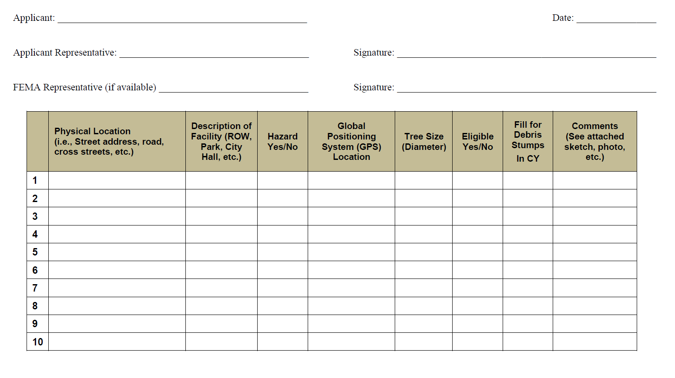
Source: FEMA Public Assistance Program and Policy Guide (FP-104-009-2 Version 4) June 1, 2020

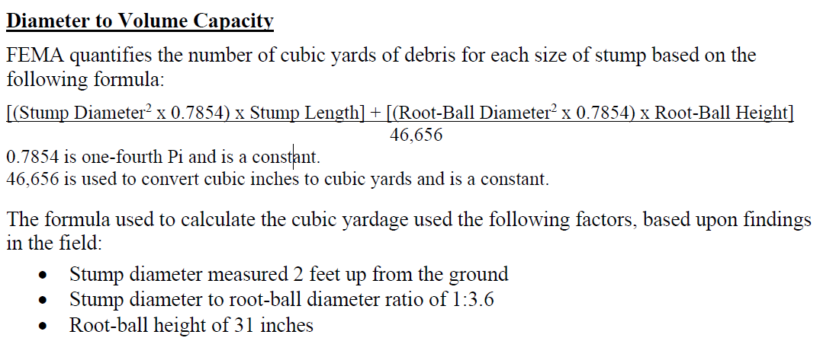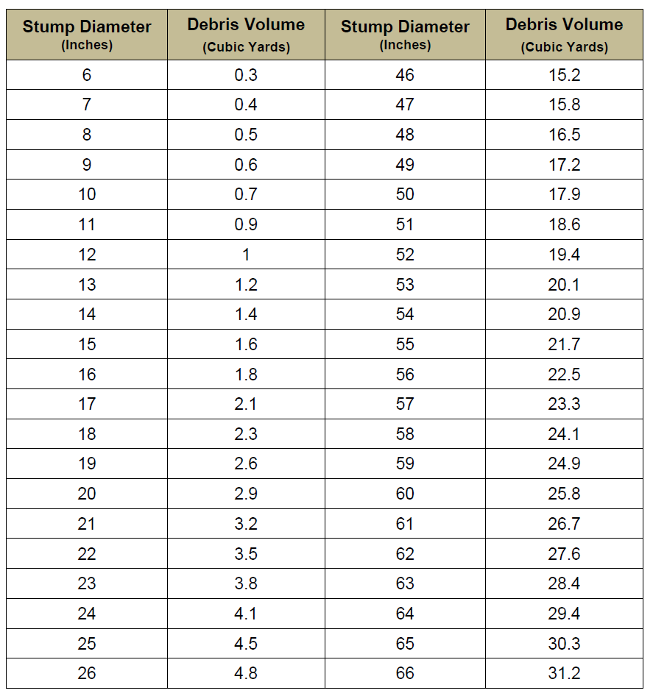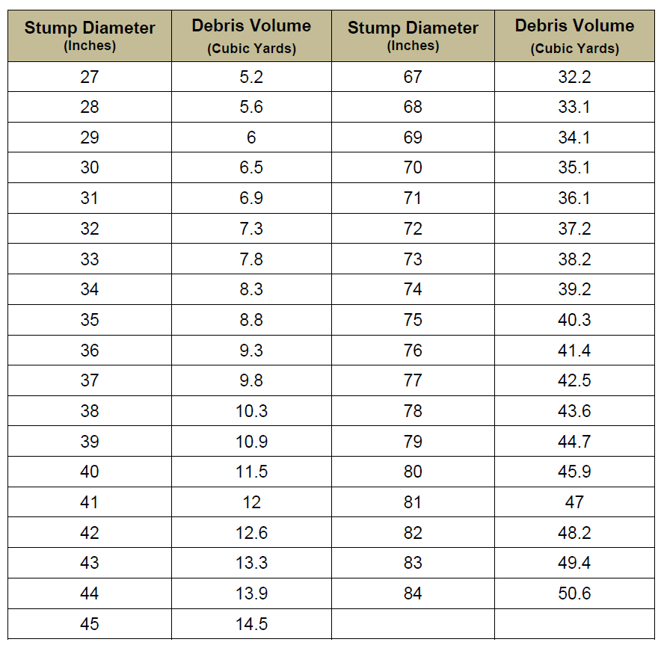
STUMP CONVERSION TABLE

Source: FEMA Public Assistance Program and Policy Guide (FP-104-009-2 Version 4) June 1, 2020
Appendix B

KEY PERSONNEL AND SME LISTS

EMERGENCY DEBRIS MANAGEMENT KEY PERSONNEL LIST

POSITION | NAME | ADDRESS | HOME PHONE | CELL PHONE | E-MAIL

POSITION | NAME | ADDRESS | HOME PHONE | CELL PHONE | E-MAIL
SUBJECT MATTER EXPERT PERSONNEL LIST

Appendix C

USACE HURRICANE DEBRIS ESTIMATING MODEL

DEBRIS ESTIMATING FIELD GUIDE, pp 9-12; “BUILDING AND RESIDENCES”

Debris Estimating Field Guide
FEMA 329 | September 2010

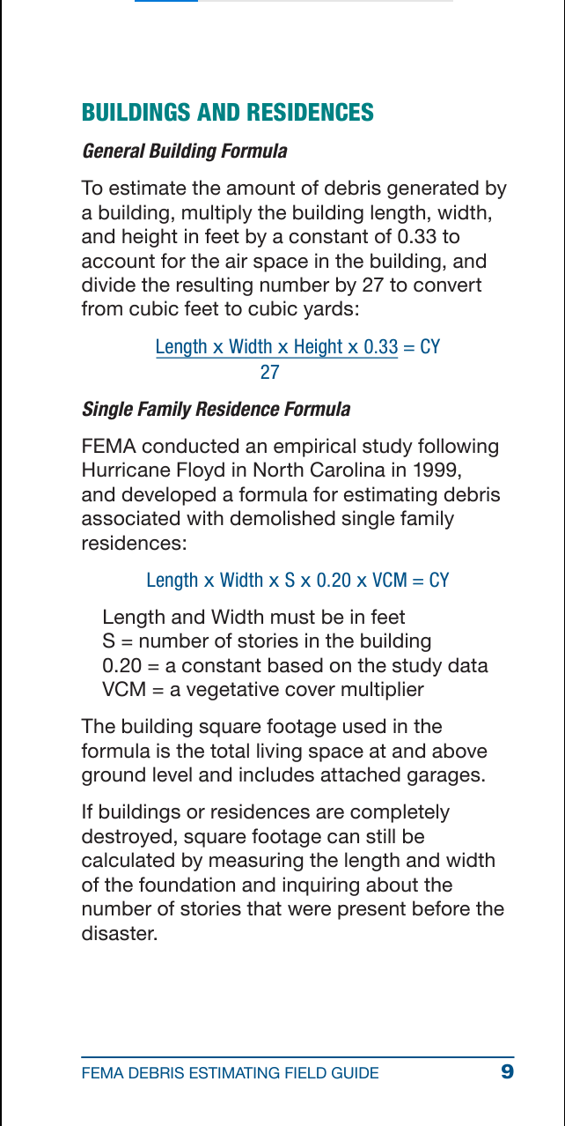
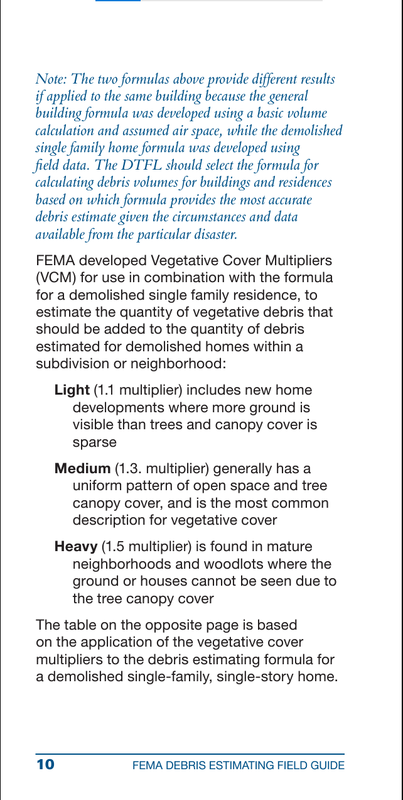
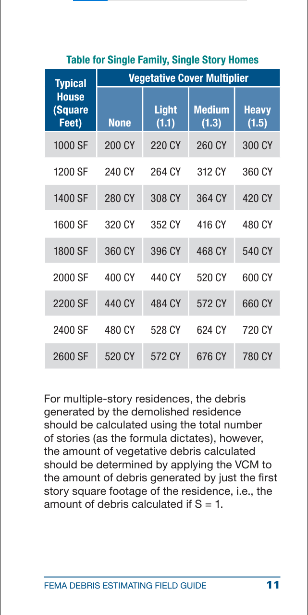
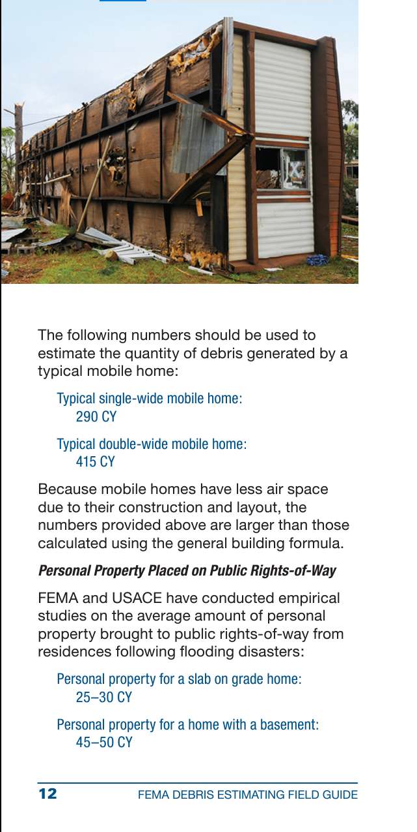
SOURCE: Debris Estimating Guide (FEMA 329) September 2010
Appendix D

CONTRACTS

Source: FEMA Public Assistance Program and Policy Guide (FP-104-009-2 Version 4) June 1, 2020

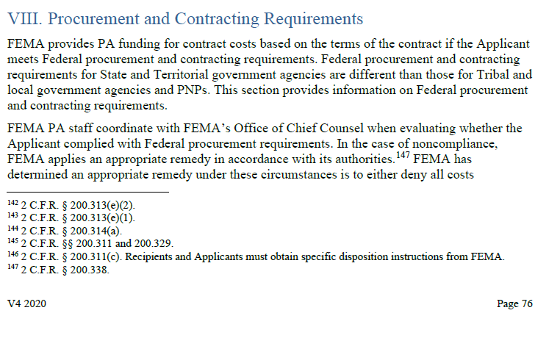

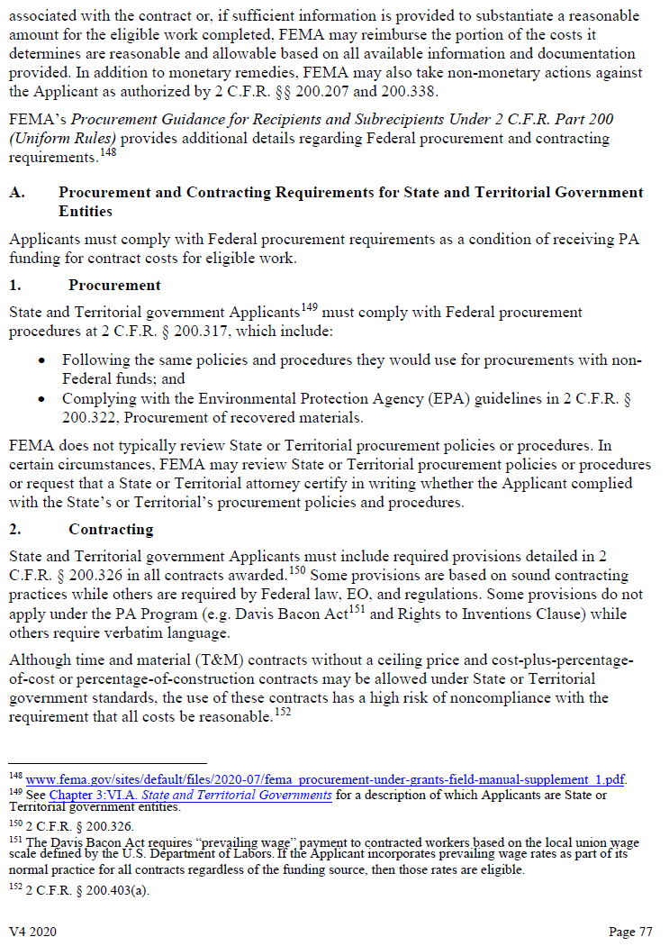
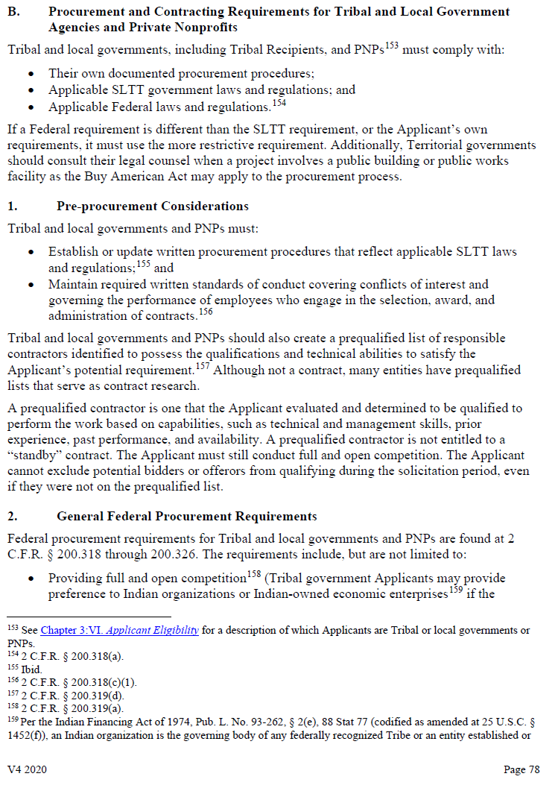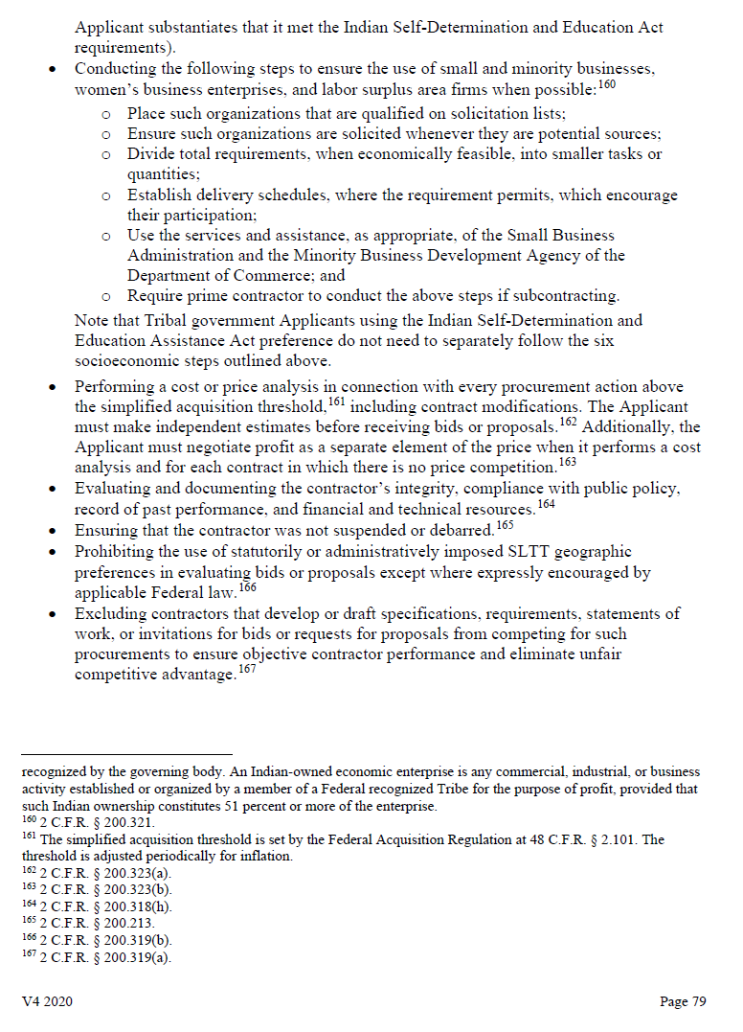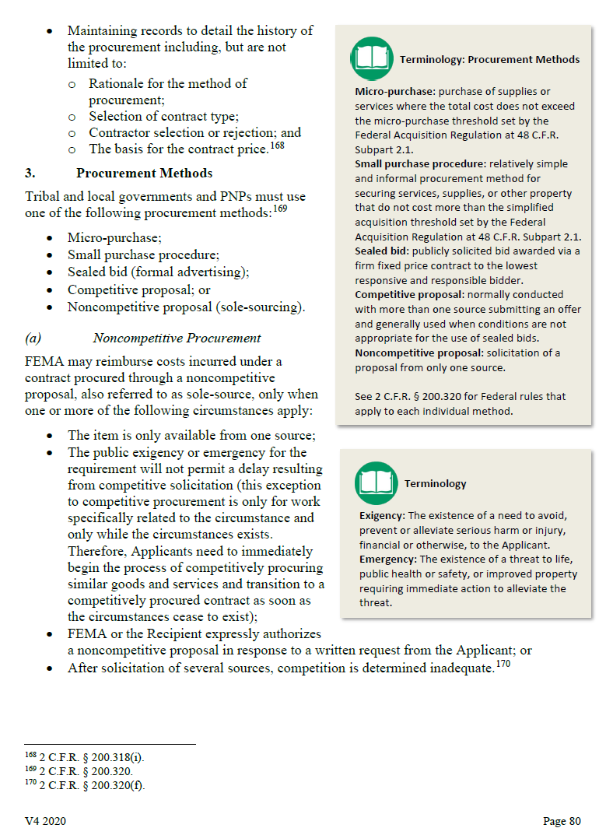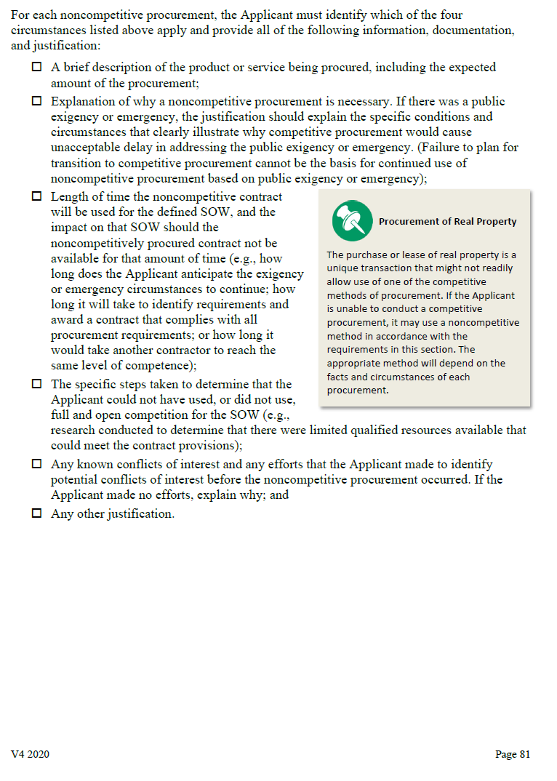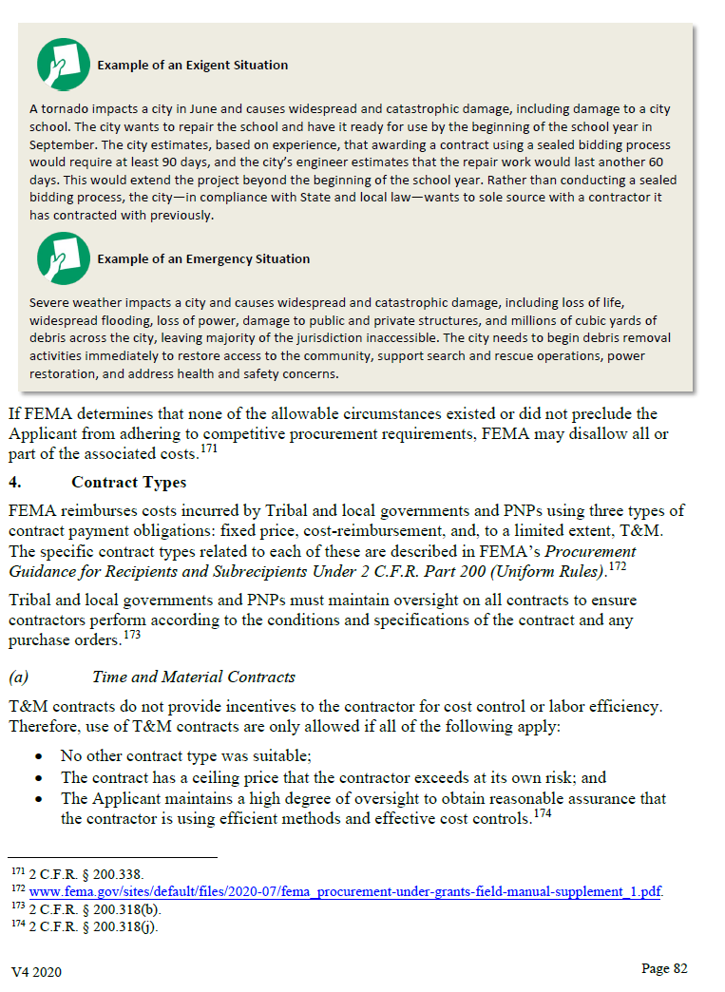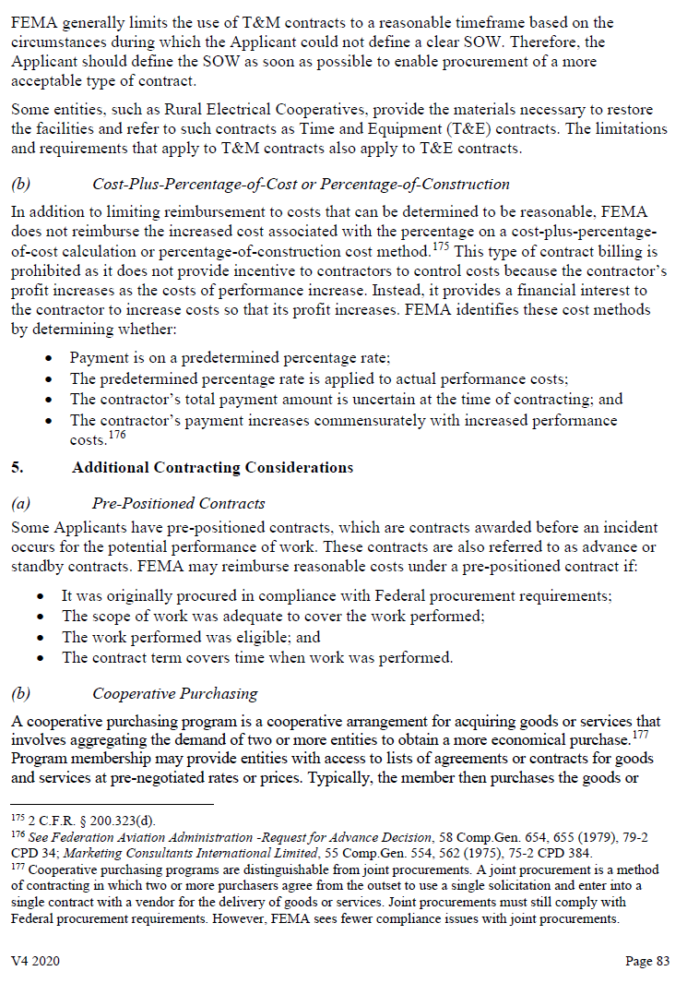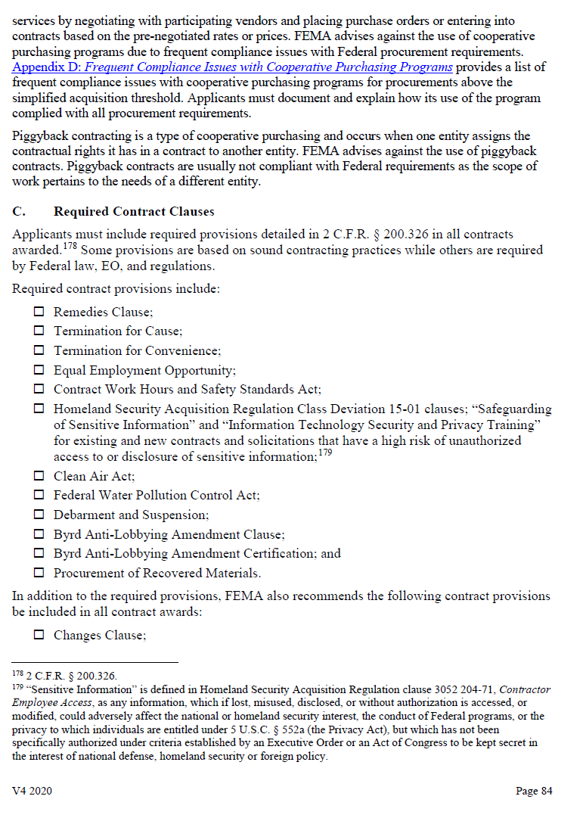
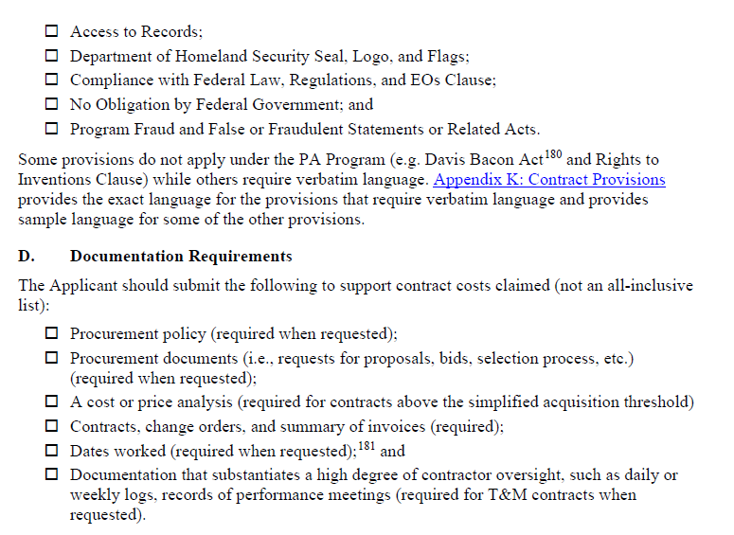
SOURCE: FEMA Public Assistance Program and Policy Guide (FP-104-009-2 Version 4) June 1, 2020
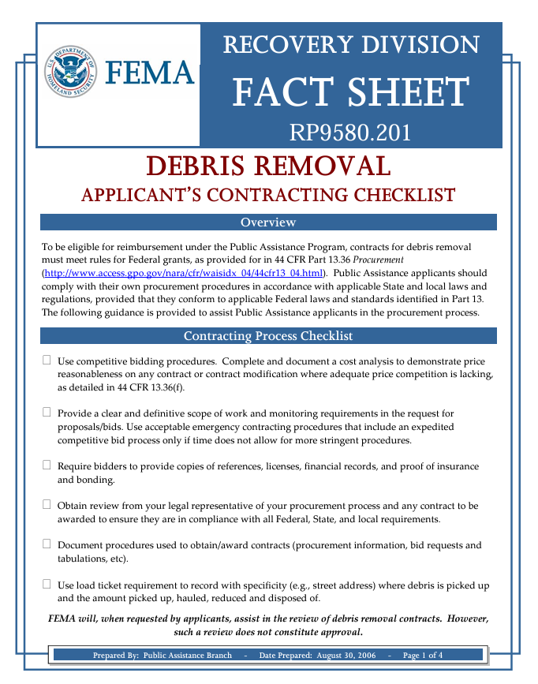
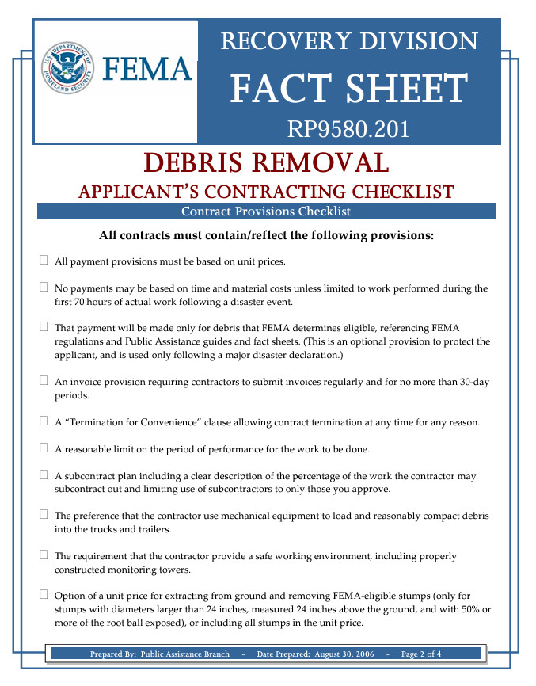
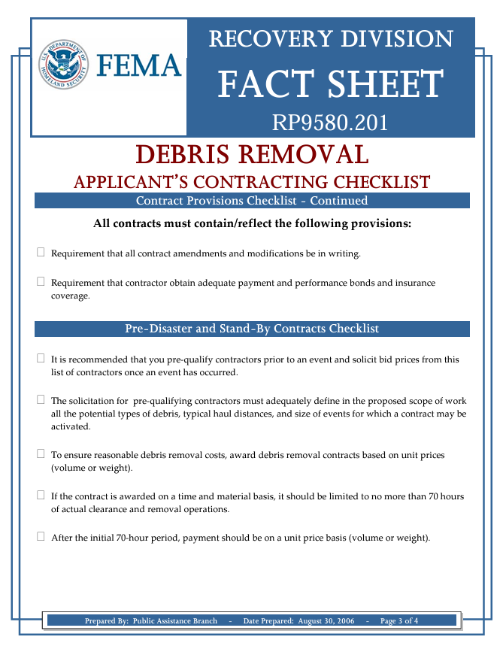
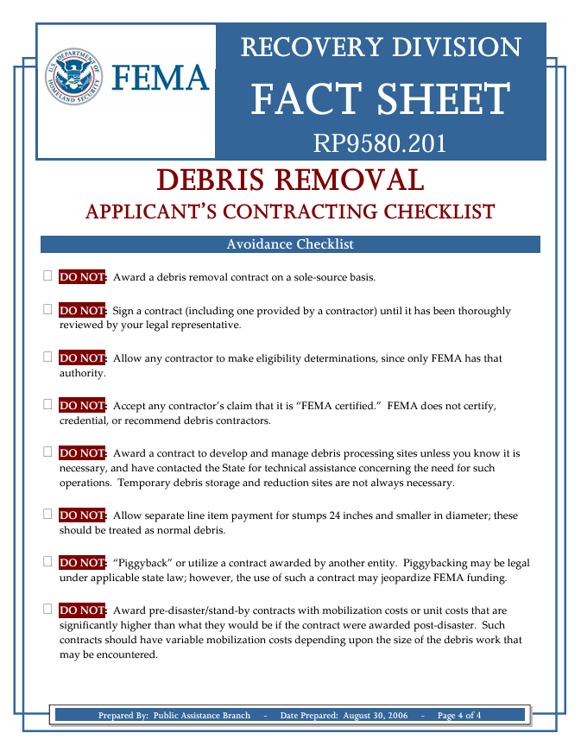
Appendix E

DEBRIS MONITORING

DEBRIS MONITORING PERSONNEL LIST

POSITION | NAME | ADDRESS | HOME PHONE | CELL PHONE | E-MAIL

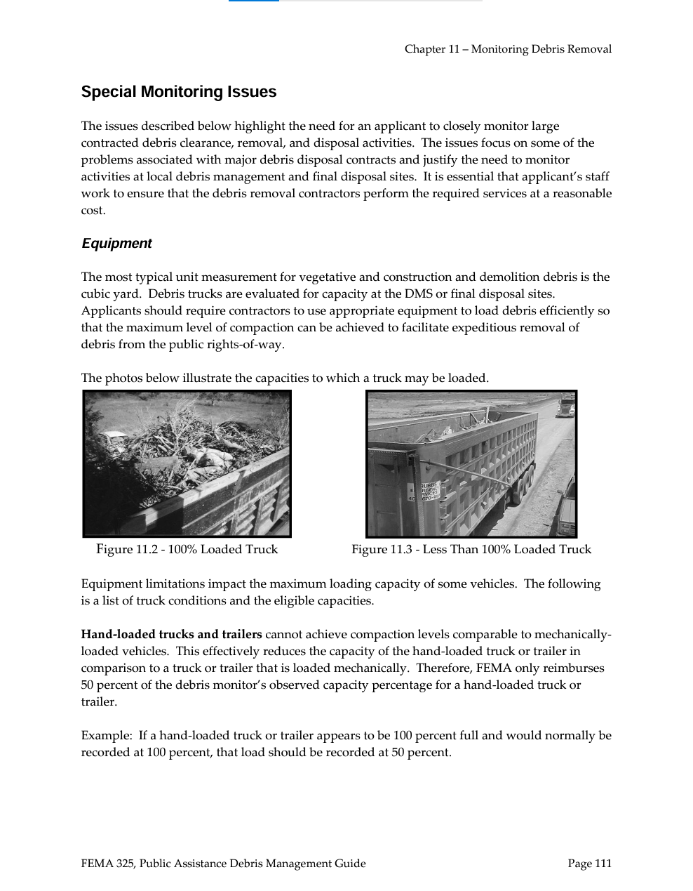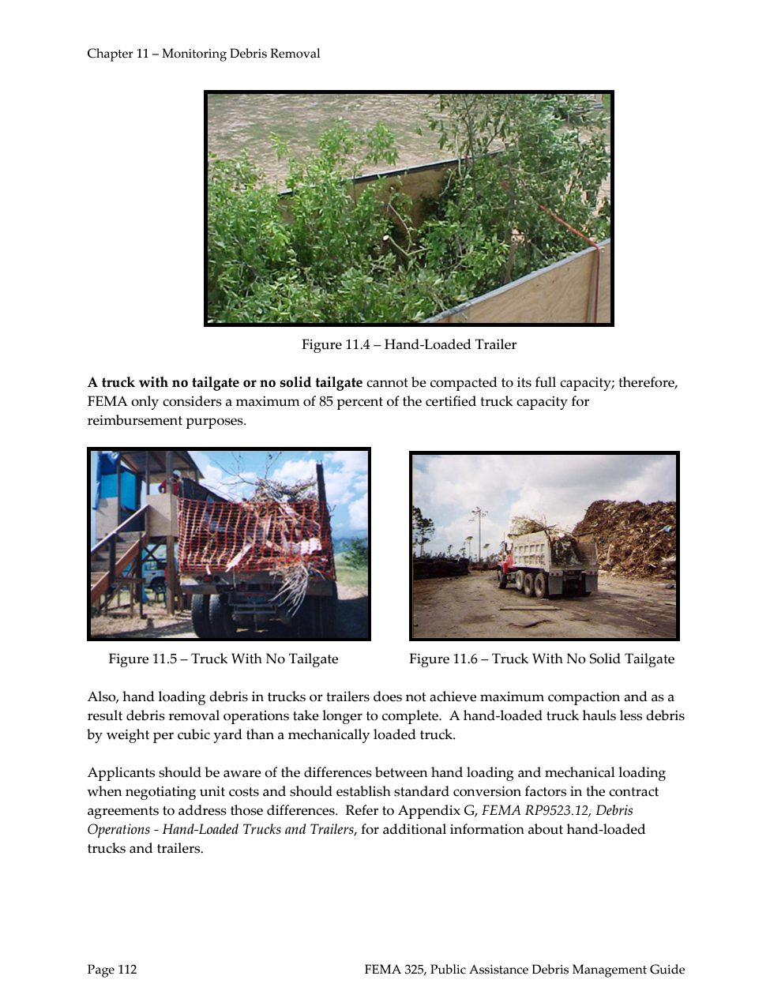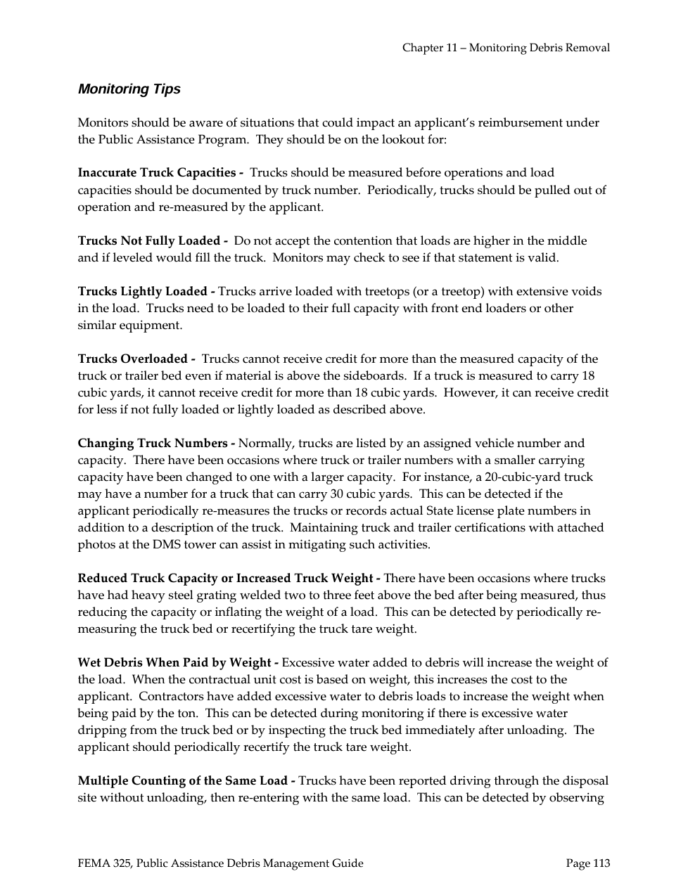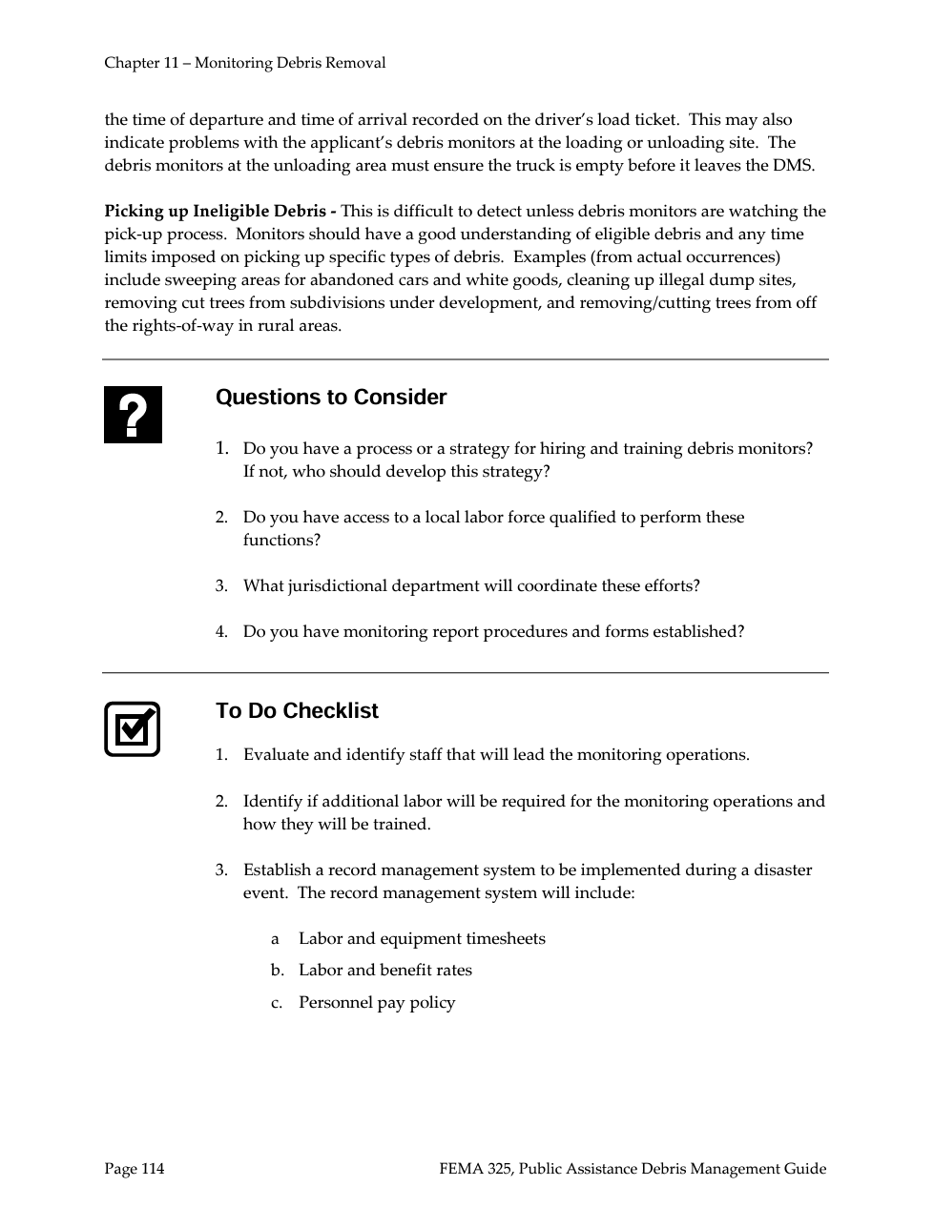
Appendix F

DEBRIS REMOVAL PERSONNEL LIST
EQUIPMENT INVENTORY SHEET
RANKED LIST OF PRIORITY FACILITIES
RANKED LIST OF PRIORITY AREAS
RANKED LIST OF COUNTY ROADS

DEBRIS REMOVAL PERSONNEL LIST

POSITION | NAME | ADDRESS | HOME PHONE | CELL PHONE | E-MAIL

EQUIPMENT INVENTORY SHEET
EQUIPMENT
SPECIFICATIONS
CAPACITY/SIZE
HORSEPOWER
SERIAL #/LICENSE PLATE #
FEMA COST CODE

Insert picture
NOTES:

Appendix G

EMERGENCY DEBRIS GENERATING EVENT PLANNING AND MANAGEMENT TOOLKIT

The current version of the Emergency Debris Generating Event Planning and Management Toolkit is available on the DEP website: https://www.nj.gov/dep/dshw/toolkit.pdf.

Appendix H

PRIVATE PROPERTY – STRUCTURE AND DEBRIS REMOVAL

PRIVATE PROPERTY ACCESS AND CONDEMNATION PERSONNEL LIST

POSITION | NAME | ADDRESS | HOME PHONE | CELL PHONE | E-MAIL

Appendix I

SPEED UP YOUR CLEAN UP FLYER
and
GARBAGE COLLECTION DELAY FACT SHEET

APPENDIX J

FORMS

